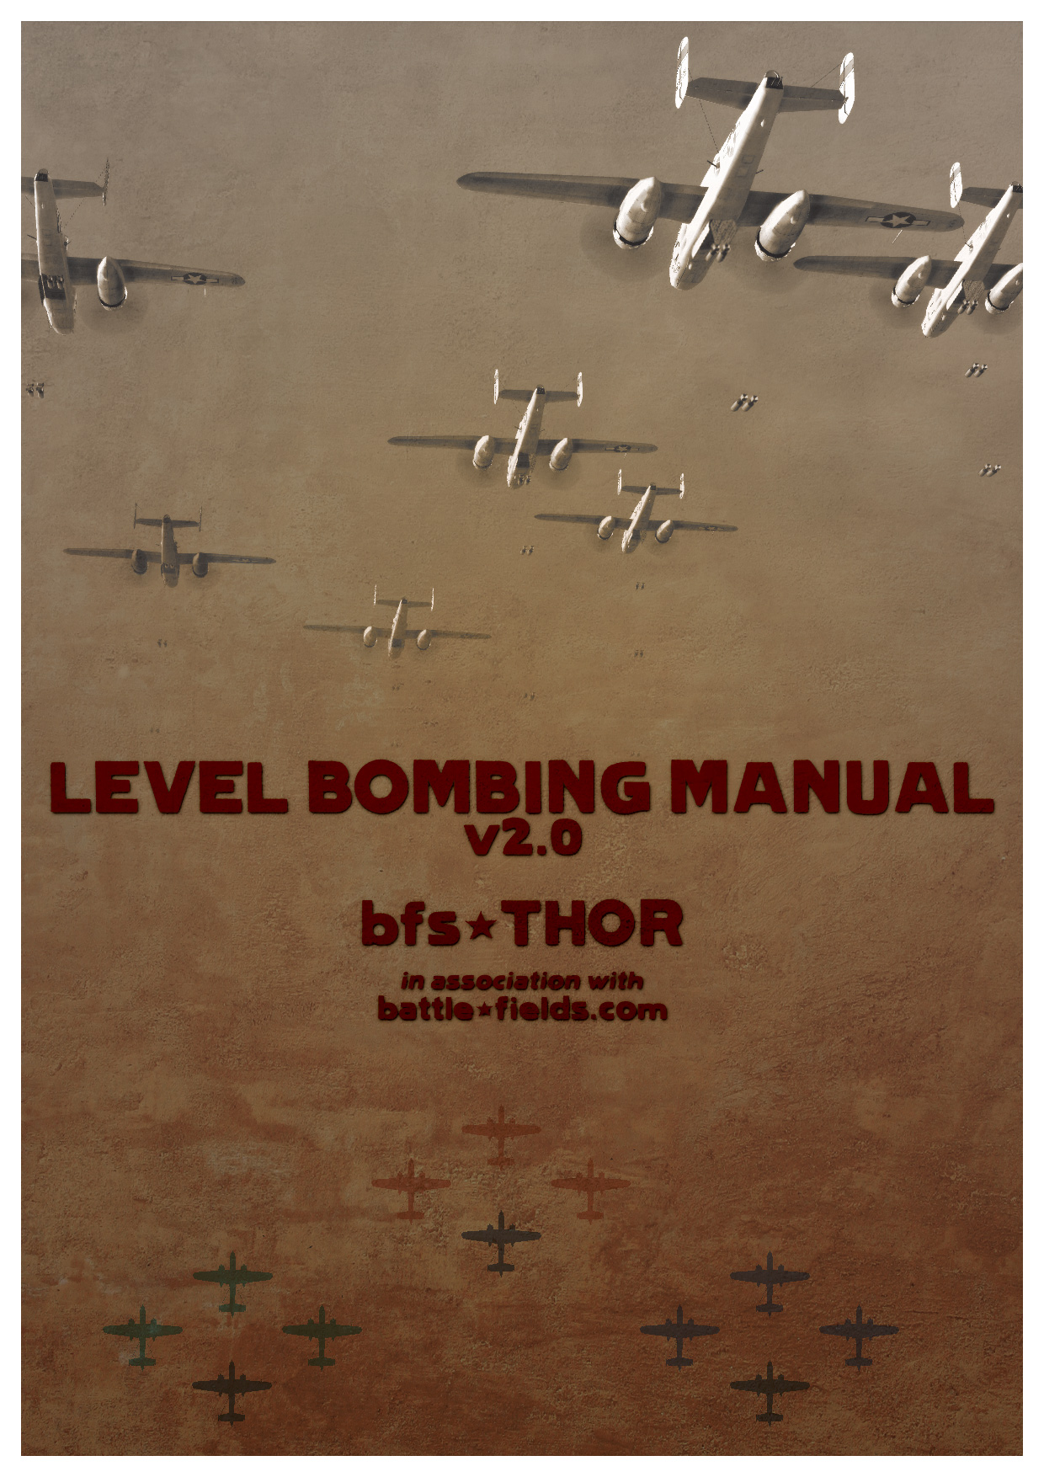
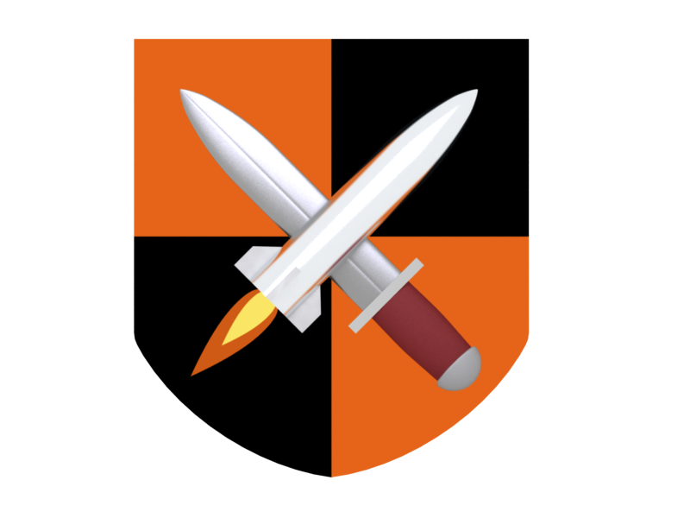

LEVEL BOMBING MANUAL

Version 2.0

T.}{.O.R.

June 2008.
INTRODUCTION……………………………………………………………………. 4
Ch. 1 FORMATION………………………………………………………………….. 6
- Formation elements………………………………………………………….. 7
  - VIC…………………………………………………………………….. 7
  - DIAMOND……………………………………………………………. 8
  - VEE…………………………………………………………………….. 8
  - VIC+DIAMOND……………………………………………………… 8
- Large formations……………………………………………………………… 10
  - BOX FORMATION…………………………………………………… 11
  - VEE FORMATION………………………………………………….... 12
  - 21 PLANE FORMATION……………………………………………. 13
- Dangers & IL-2 engine limitations…………………………………………. 14
- Positioning rules…………………………………………………………….... 15
Ch. 2 FORMATION FLYING……………………………………………………….. 16
- Forming up…………………………………………………………………… 16
  - General instructions…………………………………………………. 17
  - Large/element formations…………………………………………... 17
- Formation flying rules & common mistakes……………………………… 18
- Positions………………………………………………………………………. 21
  - Left/right wing………………………………………………………. 22
  - Tail end……………………………………………………………….. 22
  - Element lead…………………………………………………………. 23
- Leadership……………………………………………………………………. 24
  - Communication & ‘keypad grid co-ordinates’……………………. 24
  - Element leading…………………………………………………….... 25
  - Sq. leading……………………………………………………………. 26
- Specialized methods…………………………………………………………. 27
  - Steveiy's gamepad trim……………………………………………… 27
  - Flying from the nose…………………………………………………. 28
Ch. 3 TACTICS AND PROCEDURES……………………………………………… 30
- Takeoff/Landing procedures……………………………………………….. 30
  - 'Control tower'………………………………………………………… 30
  - Takeoff…………………………………………………………………. 31
  - Forming up after takeoff……………………………………………... 32
  - Landing………………………………………………………………… 33
- In flight procedures…………………………………………………………... 34
  - Switching positions…………………………………………………… 34
  - Filling empty positions……………………………………………….. 35
  - Changing formation to line astern………………………………….. 35
- Forbidden operations………………………………………………………… 36
  - Guns and level stabilizer……………………………………………... 36
  - Formation integrity…………………………………………………… 36
Ch. 4 LEVEL BOMBING……………………………………………………………… 37
- Target recon’ & pre-flight setup……………………………………………… 37
- Bomb type and delay…………………………………………………………. 38
  - Airfield attack…………………………………………………………. 39
- Single plane level bombing tactics………………………………………….. 39
  - Using level stabilizer and rudder trim……………………………… 40
  - Bomb run………………………………………………………………. 41
- Formation level bombing tactics…………………………………………….. 42
  - Deputies and element leads………………………………………….. 42
  - '5 seconds to bomb release!'………………………………………….. 42
  - Carpet bombing……………………………………………………….. 43
- Manual vs. Auto bomb release – pros & cons……………………………… 43
Ch. 5 OPERATING THE BOMBSIGHT…………………………………………….. 44
- Requirements…………………………………………………………………. 44
  - Bombsight Table 2…………………………………………………….. 44
  - BT2 & BS angle offsets………………………………………………... 46
  - Quick reference bombing chart……………………………………… 47
- Target altitude & aiming point………………………………………………. 48
- Importance of speed over altitude…………………………………………... 50
Ch. 6 BOMBERS………………………………………………………………………. 51
- A-20C…………………………………………………………………………… 51
- B-25J……………………………………………………………………………. 53
- Pe-2(all variants)……………………………………………………………… 54
- He-111H2………………………………………………………………………. 56
- He-111H6………………………………………………………………………. 58
- Ju-88A4………………………………………………………………………… 59
- G4M1_11………………………………………………………………………. 61
Ch. 7 LESSONS LEARNED………………………………………………………….. 63
- Level bombing on dogfight servers…………………………………………. 63
- Organizing a bombing event………………………………………………… 65
Ch. 8 SUMMARY……………………………………………………………………... 67
- List of needed commands……………………………………………………. 67
- Useful links…………………………………………………………………….. 68
  - Sum of all important links……………….…………………………… 68
  - Skins……………………………………………………………………. 69
  - Other BS manuals……………………………………………………... 70
  - Gunnery tutorial………………………………………………………. 70
CREDITS………………………………………………………………………………. 71

-INTRODUCTION-

I wrote this manual for all bomber pilots in IL-2 online community and those that still fly offline. Its purpose is to explain and help you successfully level bomb targets, either solo or in a formation of bombers. After over a year of experience flying in and leading countless bomber formations, and also organizing and participating in many such events which focus on teamwork and large missions, I decided to share my experiences with you by writing this bombing manual. The previous version was written when we first started to fly in (proper, not gaggle) formations on UK Dedicated servers, but lacked experience. Some things in the previous version were still ideas on paper, not proven methods in reality. Now this isn’t the case. Everything in this manual is based upon online experiences and solutions that we came up with to make formation bombing in IL-2 easier and effective. In order to accomplish the tactics described, manual bomb release is required and this is the method on which this manual is based, as it has proven its worth on every bombing run that we do. I have explained this technique in further detail than in earlier versions of this document.
This manual is written more thoroughly and in much more detail than the previous version. I also included many screenshots from our bombing runs. Chapters are sorted out by their importance, in order which someone would want, without any previous experience, to level bomb by him self, just fly in formation or even lead a group of bombers to their target and back. Almost everything related to formation bombing, concerning tactics and procedures is described here.
I noticed that some bomber squadrons are using my manual, or just the important bits from it for their own purpose. I hope that this manual provides you with even more help in level bombing. Feel free to use it for your own squad. I just like to be credited.
I would like to use this opportunity to thank the guys who run and maintain battle-fields.com, and three IL-2 servers where I spend most of my flying time. Special thanks to those that flew with me during making of this manual - Blade for hosting, Monguse for his excellent B-25 skins, Letum for printable charts and other visual enhancements in the manual, and Magnum for excellent cover. Also thanks to Steveiy for his contribution to the manual and pointing me to some things I missed out from version 1.1.
This manual features over fifty pages of text. If you are not interested in certain chapters just look at the index page and find what you are interested in. I have tried my best to make things as simple as possible and easy to understand, but if you have some questions contact me through battle-fields.com forums or post a comment in the main thread about this manual on www.battle-fields.com Enjoy your reading!

Author

Main thread, link:

http://www.battle-fields.com/commscentre/showthread.php?p=207106

Chapter One:
-THE FORMATION-
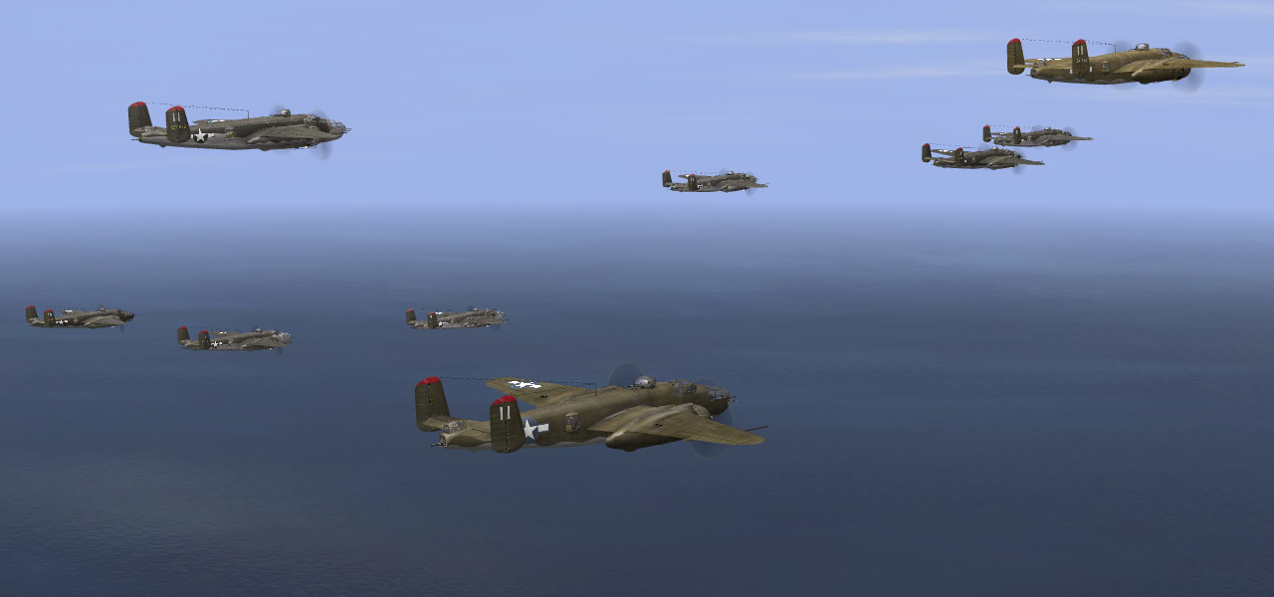

To understand how level bombing in formation works and before you even begin flying in one, you need to know what a formation is, how it is laid out, and how it functions. Formation data and formation charts shown here are based on actual USAAF (8th AF mostly) and LUFTWAFFE formations used during World War II. If you are only interested in single plane level bombing, then you can skip to Chapter Four.

Formation elements

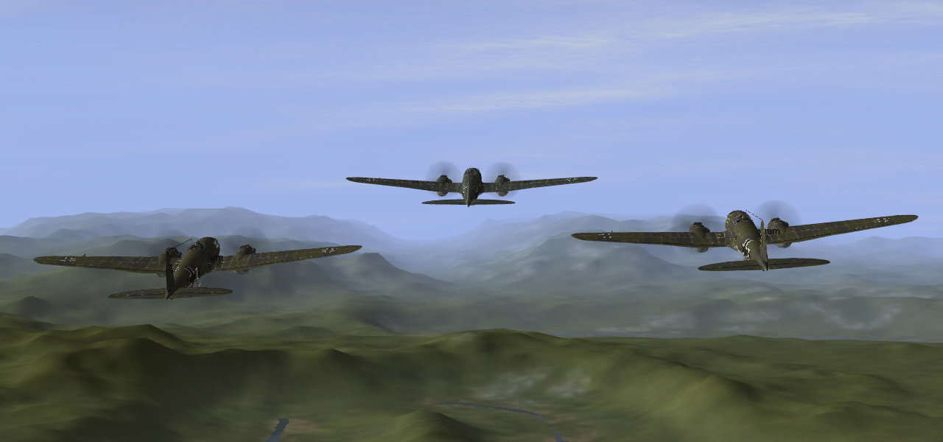

The basic element consists of three planes flying in close formation. It is called an element formation. Elements are not limited to only three planes and up to seven planes can form an element. I will first explain the basic three plane element.

VIC
Planes following the leader each position themselves on one of his wings - this is called ‘flying a wing’. When flying wing, following planes are positioned 45° (135°) of leader’s flight path and behind him (45° from his 6 and 3/9 o’clock, depending on the wing). Distance between planes in element formation, measured from nose to tail, and wingtip to wingtip, is ‘half a wing’ (half of your aircraft’s wingspan), and it is marked as ‘X’ on the pictures below. All three planes fly at the same altitude, parallel one to another. This basic three plane element is called a VIC. See the picture below:

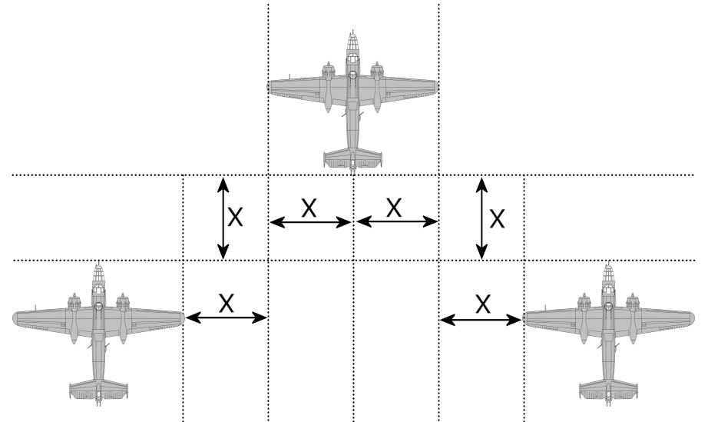
DIAMOND
When four planes form an element, fourth plane is positioned directly behind the leader, at half a wing distance behind planes flying a wing - 45° (135°) of their flight path, and their 6 and 3/9 o’clock (between them). First three planes fly at the same altitude while fourth plane flies ‘half a wing’ altitude lower, with all four planes on a same distance between each other.

VEE
In the Luftwaffe, during the Battle of Britain, bombers flew in five ship elements. Five ships form a VEE. It consists of two plane echelons flying on both leaders’ wings. Distance and spacing between those aircraft is equal to when flying a wing. Only this time, there is another plane flying a wing on each side. All five planes fly at the same altitude and on a same distance between each other.
Five planes is the realistic limit when setting up a VEE element. Seven or more planes can fly a VEE in IL-2, but require a lot of skill.

VIC + DIAMOND
A more feasible seven plane element was used by the 8th AF during WWII. In this seven plane element, the leader and his two wingmen fly at the same altitude to form a VIC formation. Number four's position is the same as in the normal four plane element with the only difference being that now he will have two planes flying on his wing. Number seven, the last plane in this element is positioned half a wing lower than numbers four, five and six (second VIC). In relation to them, his position is just like number four in a DIAMOND formation. All planes are at the same distance between each other and separated into three groups, each group flying at a different altitude. In short, this formation can be described as VIC + DIAMOND.

All four elements and their differences can be seen here:

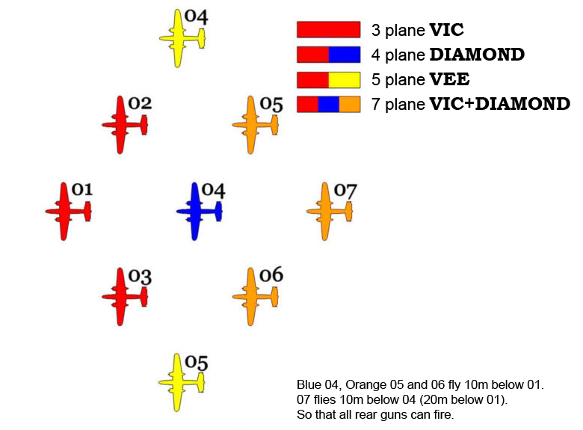

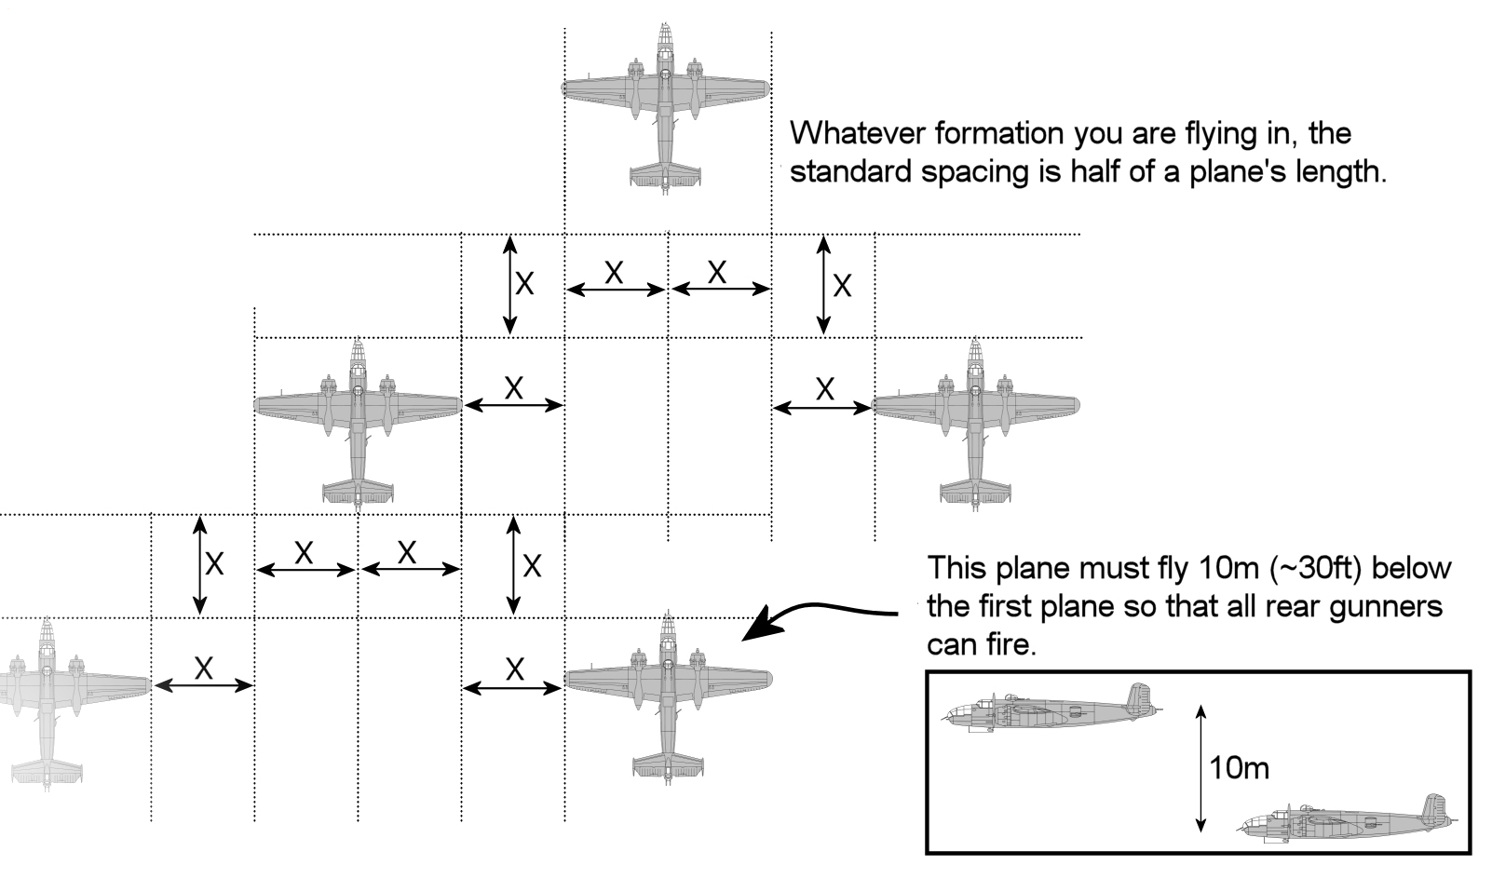

Large Formations
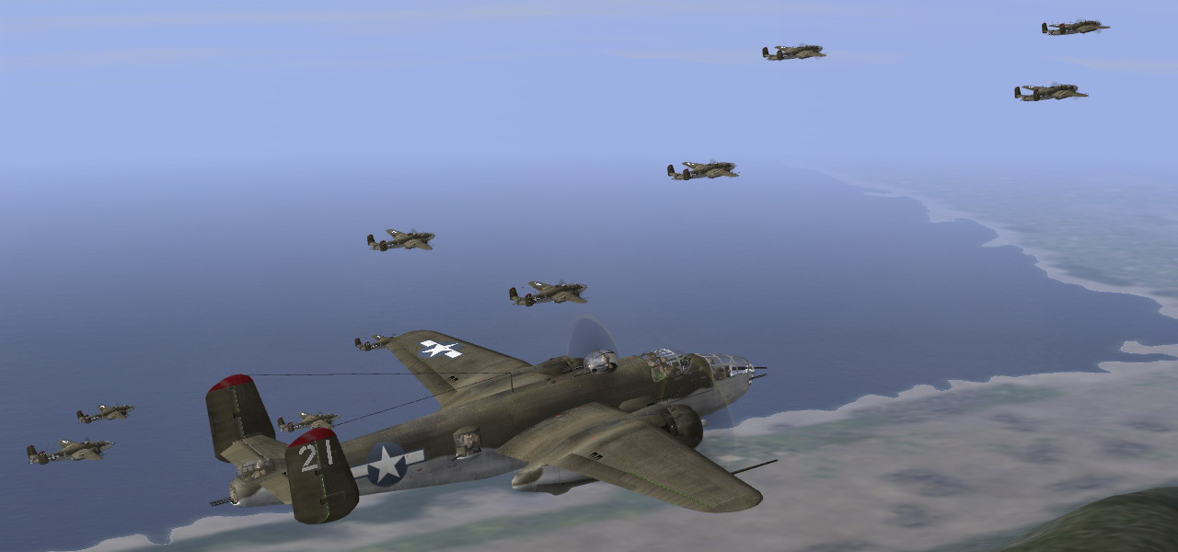

A large formation consists of many elements flying together. This subchapter will show you diagrams and formations charts specifically designed for IL-2. All of them are based on historical formations flown by major forces utilizing formation bombing in WWII.
For easier reference, like in World War II, elements inside large formations have been denoted by different colors. Red, blue and green were standard colors used in 8th AF. Red was the leading flight and blue/green were used by other elements following it. Positions inside elements are designated with numbers from 1 to 7 (I have put seven as limit on the number of planes in one element). When flying in large formations, plane positions are also denoted by colors. Example: Red 4, Blue 2, Green 5 and so on.
In diagrams shown here, planes have been assigned their fuselage numbers to go along with their position numbers. All planes flying in lead (red) element have number 1 in front of their position number, all planes flying in second (blue) element have number 2 in front of their position number and all planes in third (green) element have number 3. Example: ‘11’ stands for Red 1, ‘34’ stands for Green 4, ‘23’ stands for Blue 3 and so on. Those numbers should be used in game when flying in large formation, especially on servers without icons.
For easier usage, you can download printable versions of each formation shown, to write down pilot names in their according formation positions.

BOX FORMATION
In the 8th AF, the basic formation was called a ‘BOX’. It consisted of four three plane elements flying a large diamond formation, with all four elements at different altitudes. This was created to enable better defensive gunfire and to make it harder for enemy anti aircraft guns to hit them. Early war BOX formations consisted of four VIC elements flying on different altitudes. Later in the war, a fourth plane was added and the formation consisted of only three DIAMOND elements. Therefore I have put only nine planes in the early war formation, which may be transformed into a late war BOX formation if required by the number of planes participating.

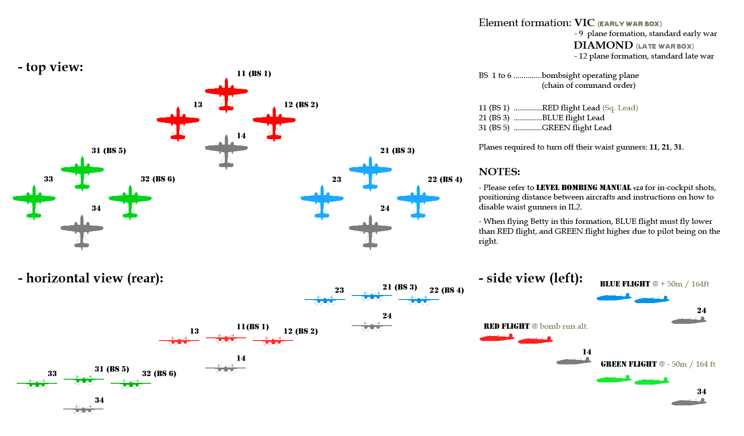

VEE FORMATION
During the Battle of Britain, Luftwaffe bombers flew mainly in five ship elements (VEE), one element behind another and every element on a different altitude with leaders’ element being the highest. This formation was also used by US 15th AF, which mainly flew B-24s. It was later, before the end of the war, adapted to the 8th AF. Luftwaffe formations were formed by up to five such VEE elements. I have placed a limit on only three elements, denoted by color - red, blue and green.

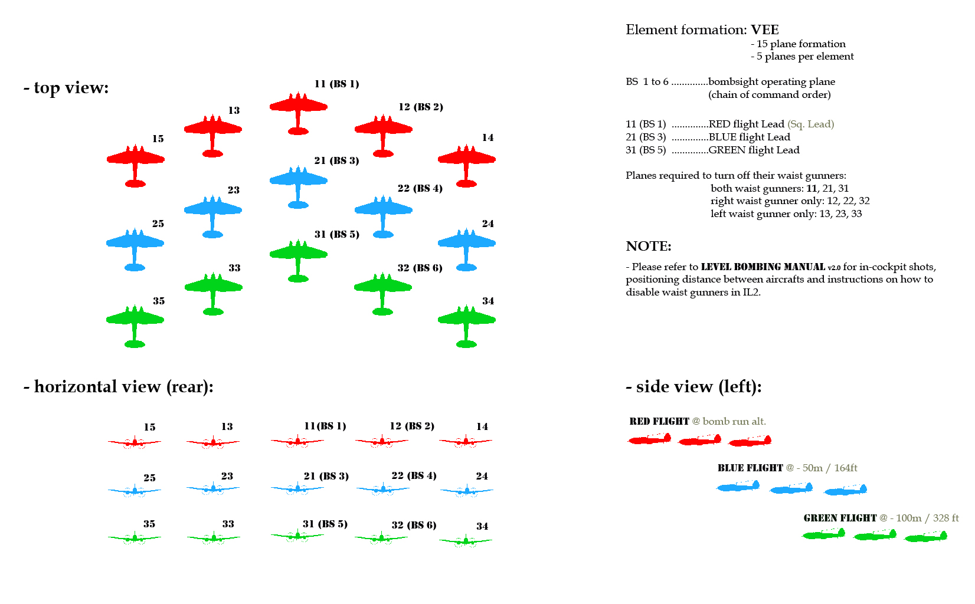

21 PLANE FORMATION
Although used by heavy four engine bombers as well, this formation was mainly used by medium bombers in the USAAF. Medium bombers usually flew in seven ship elements (VIC + DIAMOND), where three such elements formed a large formation, with each element on a different altitude, much like the (early war) BOX formation shown previously, but with larger altitude differences between elements.

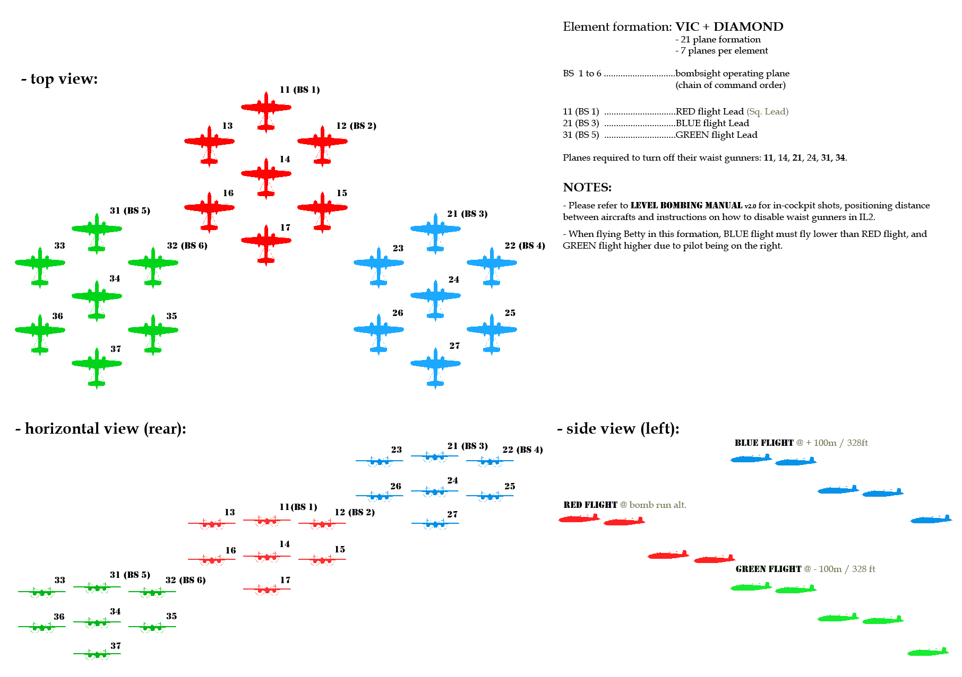

- High resolution and simplified printable (A4) versions for squadron/element leads can be found in FORMATION CHARTS attachment.

Dangers & IL-2 engine limitations

Flying in formation in IL-2 requires some adjustments to the formations flown in real life. The first is not being able to fly from your copilot's seat. For example, this means that you won't be able to see what is to the lower right of you (from 2 to 3 o'clock) when you fly a B-25. For this reason the right element in any formation must fly higher than the lead element. The left element then flies lower than lead, because it can have lead element in sight at all times. However, the pilot's seat in G4M1 is positioned on the right side which requires that the element altitudes used be the opposite of those used with the B-25.
The biggest danger in formation flying is waist gunners. As you’re probably aware, there have been numerous discussions on all forums about gunner accuracy in Il-2. They are not only too accurate at certain occasions and angles, and G-forces don’t affect them, but they also don’t take into consideration friendly planes flying nearby. This creates a danger when flying in formation and your gunners start to become your enemies. Fortunately this only applies to leading planes, planes flying on positions two and three in VEE formations and to number four in seven plane element formations. Those planes must disable their waist gunners before joining the formation. To do that you need to deactivate autopilot automation function in IL2. This will keep your gunner under AI control (autopilot) until you manually deactivate them. They will remain deactivated until you press autopilot key again or reactivate autopilot activation function in IL-2. This is best done while still in cockpit, before switching to gunner positions for deactivation, and before joining the formation.

- Toggle Level Autopilot command can be found under MISC controls in IL-2 and needs to be assigned a key manually.
- Toggle Autopilot command is set to key ‘A’ by default.

If you’re forced to leave the formation, waist gunners can be reactivated once again.
Lag is probably the most known danger of online formation flying. Sometimes it cannot be avoided, but there are procedures to compensate for it. In a year of online formation flying I saw many more bombers lost to team killing waist gunners than lag. Procedures on how to avoid lag can be found in the next chapter.

Positioning rules

Formations look nice on paper. But in real life or in the virtual skies of IL2 in this case, things aren’t so simple. Certain rules must be followed to fly properly in formation. And these mainly apply to the individual pilots’ skill of formation flying. This means the best formation flyers will be assigned the best formation positions. This was also the case in real life. The worst and most exposed positions are at the end of the formation. Those positions were usually given to novice pilots with little combat experience and lesser formation flying skill.
With formations numbering up to 7 bombers a large briefing isn’t needed. However, when you're dealing with 20+ bombers in a formation, a briefing is a must. It is best to assign positions before the actual mission, as this process consumes a lot of time. Therefore I have included printable (simplified) versions of formation charts with boxes to put pilots’ names into.

Here are some guidelines on which you should assign positions to pilots with good formation flying abilities:
- When formation consists of one element, the best formation flying pilots must be placed on leader’s wings (numbers 2 and 3).
- If there is more than one element, first element must assure the ability for other element leads to fly in their positions. ‘Loose’ Tail end Charlie(s) flying all over the place are not helping.
- Element lead positions must also be given to those pilots that are able to judge proper distance and hold their element in place.
- In order of importance, the toughest position to fly is sq. lead, element lead being second and then wing positions.
- Assure that sq. leader has a well trained deputy on his wing who also knows how to operate a bomb sight. If possible two of them. Same goes for element leads.
- Use in-game fuselage numbers with their according denotation as described in large formations subchapter - just like on the formation charts. Since Luftwaffe planes use alphabetical letters, it is best to write fuselage numbers down on the printable formation charts. I recommend using numbers from 1 to 25 as all larger ones transform into Zs. Another option is to use different squadrons (1 to 4), because they will show insignia letters in different color.

More on different formation positions in next chapter.

Chapter Two:
-FORMATION FLYING-
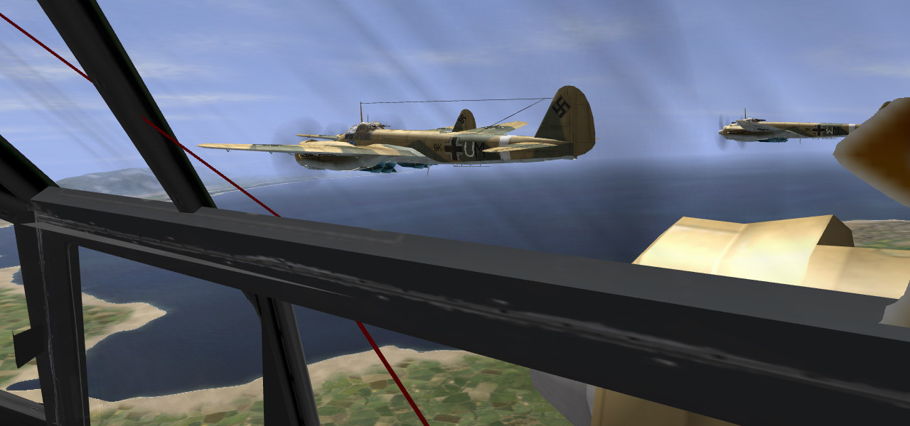

The most effective use of a bomber, both offensively and defensively, is when it acts in team as a single unit. Consequently, knowing how to fly in formation is a must for any bomber pilot. It not only produces tight bomb patterns, but also provides cover from enemy fighters by combining defensive firepower from two or more bombers. In this chapter I’ll describe how to fly in formation. Before you read further, I recommend that you watch this USN Training Film dating from year 1953. (25 min running time)

http://video.google.ca/videoplay?docid=-1997892837826774725

Some of the things written here are already mentioned in the USN formation flying tutorial video, I adjusted them for IL2 use.

Forming up

Before you can fly in the formation, you have to know how to get into the formation. After assigning positions, forming up is the first stage of formation flying. It can be done in the air or from the ground, by formation takeoff. Either way, it is a very important part of formation flying and should be learned first.
Depending on the given situation both tactics have their own advantages, while still on the ground, or in the air. Formation takeoff is described in 3rd Chapter, under Take off / Landing procedures section, and RV in predefined grid method is in the video above.

General instructions
When closing on the formation it is vital to know its current speed and your approaching speed, or you will end up overshooting the formation. Sq. leader will give out his settings. If not, try to always be in contact with the plane you’re following. Ask for the power, prop pitch, radiator and trim settings. If you see that you will overshoot, kicking hard rudder and cutting power to 0 helps to slow your plane down. After you have slowed down to the speed of leading plane adjust your throttle slowly and decrease/increase when needed. With little flying experience even pilots with less skill should have no problem in picking this up and learn to predict throttle adjustments. If you do happen to overshoot, don’t do any crazy maneuvers like pulling up or anything similar – nobody wants a mid-air collision. Cut throttle and wait until formation starts gaining on you. Then adjust throttle accordingly.
When not using tactics described in Chapter Three, usually you will be forming up from sides, or from formation’s 6 OC. If you are coming in from 3 or 9 OC, don’t turn in the last second trying to assume your position – this will often make you overshoot the formation. Try and guess best possible intercept course so you can form up easily
The most important part of forming up is to cut corners. This means you need to fly to a spot where formation or leading plane will be after short time interval and fly to it on an intercept course. This helps to greatly speed up the forming process. If you’re leading the formation, don’t hesitate to give instructions and your flight plan to pilots following you.

Large/element formations
When assembling a formation consisting of only one element, the procedure is simple. Planes join and form in order in which they are assigned to their positions. This means that planes closer to the leader (lower tail number) join first, and after that planes following them start joining until everyone is in place.
Forming up a large formation that consists of more elements is a rather tricky thing to do. What we have learned through experience is that if you form up on your leader (sq. or element) and then merge elements together it takes very long. The faster and more ‘pilot friendly’ method is to get element leads together with sq. leader first and put them in their proper position. This is especially useful when flying without any icons. With this procedure, every pilot that joins the formation will immediately know his position and be able to fly to it without any confusion. There is another large benefit of this, which is preserving the formation's backbone. Large formation consists of more elements flying together as one single formation, not every element on its own. Element leads are following their sq. leader and fly just like they are inside his element, only at a larger distance. Planes inside elements follow their element leaders, and their instructions.

Formation flying rules and common mistakes

Before attempting to fly in a formation it is vital to know these rules listed below. Most often, people that are "afraid" of formation flying do not follow these rules. If you follow them you will find that it is much easier to hold proper position inside a formation and your hands won’t sweat anymore.

1) Know your plane!
Have you ever wondered how the rest of the guys have no trouble in following the formation at given power setting? The reason for this is a properly trimmed plane. A properly trimmed plane flying straight and level can be up to 20-30 kilometers per hour faster. Know your plane and learn how to trim it for certain speeds. In formation flying this means no more than 70-80% power and climbing at those power settings. Bear in mind that trim adjustments are needed as speed and altitude of your plane change. Higher the speed - less trim, higher the altitude - more trim. Throttle setting also has an effect, as more engine torque requires more trimming. Usually no more than 4 clicks on keyboard are needed for trim changes in level/climbing flight.
For that reason I have included trim settings for every bomber described in this manual for straight and level flight. Settings shown are for keyboard trimming, which I suppose most people use for trimming their planes. See Chapter Six for more information about trim settings for cruise speed.

2) Your leader’s wings are your horizon!
A fundamental rule to formation flying is to keep your wings parallel to your leaders’ at all times. This is called ‘flying a wing’ as previously mentioned. You will find you have a tendency at first, when flying wing, to fly with your inboard wing down. This causes your plane to move towards your leader. Attempting to correct this by adding outside rudder causes your plane to skid (fly sideways). Meaning you’re actually ‘braking’ with your plane and this requires more power to fly at same speed as your leader. Use ailerons to keep your wings leveled with your leader’s wings. His wings are your horizon! With your wings parallel to your leader’s wings very little throttle, stick and rudder adjustments are needed to correct for any relative motion. After ailerons, RUDDER is the most important control surface when holding formation. Don’t forget that if you apply excessive rudder it will act as a brake and slow your plane down. By following this rule you will find holding position much easier.

3) Rules during turning.
When turning in the formation, in order to hold your position properly you are required to increase or decrease your altitude, depending on the turning direction and your position in the formation. For the example, if you’re flying right wing and the formation is turning left (as shown on the images below), you must bank your plane on your leader’s axis and increase altitude in order to keep him in sight. This puts you on the outer turning circle and you’re also required to power up for maybe 10%, depending on the bomber and the position. The further away from the sq. leader you are, the larger the throttle change that is required.
In a left turn, if you’re on the left wing you must decrease your altitude to keep your leader in sight, and also chop throttle by usually no more than 10%, but don't hesitate to chop more if needed.
If you’re flying in an element, you must follow your element lead and turn just like you would follow sq. lead if you were flying in the main element. Only difference is that element lead also gains or looses altitude depending on your element position, so keep that in mind.

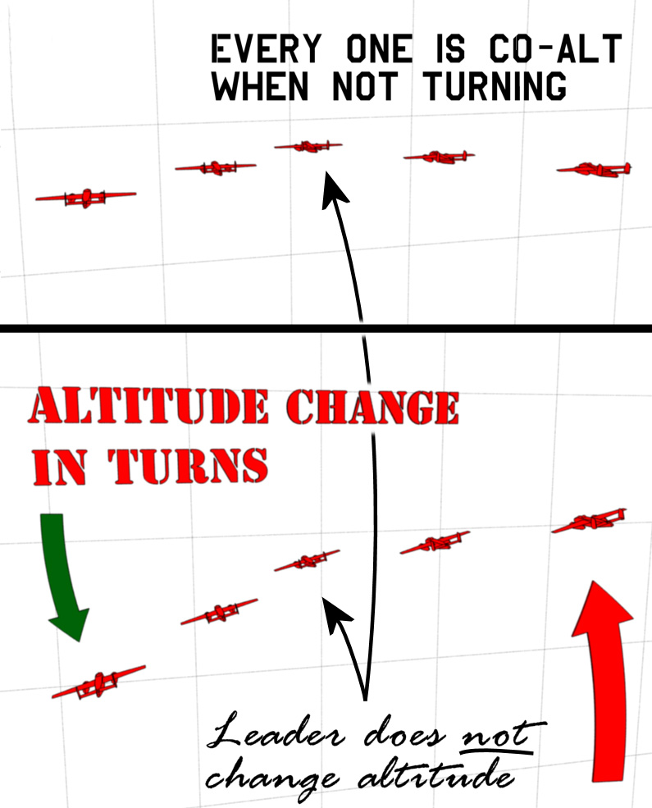

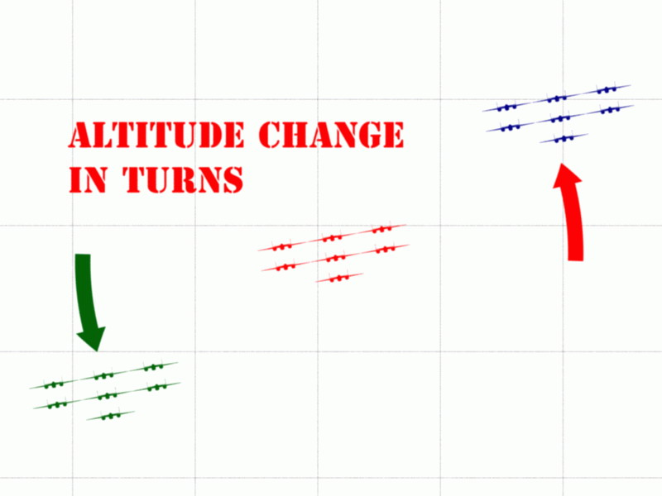

4) Energy state.
Sometimes, when you join the formation you will notice that in spite having the same fuel and bomb load you have to use less power to hold the position. This often happens if you join the formation from a higher altitude or with a greater speed and when your leader has been climbing for long time period. This is nothing to worry about, your energy levels will equalize in short time.

5) Never cross your leader’s six o’clock!
This rule applies when you’re flying wing and is the most important safety rule to follow. Crossing the leader’s six o’clock may lead to an immediate collision if the bomber on the other wing isn’t keeping his proper position!

6) Avoiding lag.
Probably the biggest problem of online formation flying is lag. It can break up the formation in only a few seconds. Plane which is lagging will pop up into its slot after a couple of seconds so the best way to compensate for it is to keep your throttle at the same power setting together with altitude and heading.
There is a clear distinction between planes lagging and flying normally in game. This can only be learned by experience. You will soon be able to tell when someone is lagging, by either speeding up too fast or slowing down suddenly. Just keep your head cool and act as though the plane lagging is in its place.

Positions

Often, when attempting to fly in the formation some pilots have trouble judging proper distance and angle from the plane they are following. Some have it naturally and some don’t. If you have trouble in holding your plane in a proper position or on a proper distance when flying from cockpit, put the plane you’re following into a predefined position on the windshield. This was done in real life as well. Pilots often put marks on their windows where leading plane needs to be in relation to their plane. For this reason I have included in-cockpit shots of three most important formation positions, for all bombers described in this manual. These are: right wing, left wing and tail end position. In-cockpit screenshots can be found in the same directory where you extracted this manual. Here are descriptions and explanations of each position.

Left/right wing
When comparing left to right wing position, right wing is much easier to fly. Reason for this lies in the fact we don’t have an option in game to choose from pilot’s and copilot’s seat. Almost all planes besides G4M1 Betty have their pilots placed on the left side of the cockpit. Ju-88 is an exception, where we have an option to switch to bombardier’s position. Therefore, most planes have better visibility to the left side of the cockpit because it is easier to put the plane you are following between cockpit bars and windows when flying on the right wing. Although I find flying on left wing much easier in Ju-88 from bombardier’s position, the lack of any bars on the right side in Ju-88 cockpit still causes problems to some. The best way to establish proper wing position is to orient yourself on the plane you’re following. When doing that, try to position your plane in 90° angle formed by the trailing edge of the leader’s wing and his fuselage.
Left wing is probably the toughest position to fly in any element formation. This is due to IL2 engine limitations and things I already described above. It should be given to pilots with best formation flying abilities. If you’re flying G4M1, this position should become one of the easiest to fly. Unfortunately, G4M1 cockpit has a large bar placed where you must put the leading plane and because of that this position is still harder to fly than right wing. However, it is still possible to follow the lead plane in spite of the obstruction.
The best advice when flying on a wing position is to set your view 45° left or right of the gunsight (center view), and position the leading plane in the center of your screen. That way you will position yourself on a 45° (135°) bearing from his flight path.

Tail end
Tail end positions are always given to the novice pilots and are easiest to fly. They are also the most exposed positions and when flying in tail end position you have the best chance of getting shot down. Although it may seem simple, flying on tail end position doesn’t mean you just have to follow the plane ahead. This position is also defined by exact altitude and distance from the leader. If you position your plane correctly you will find that your plane has far better chance of survival. Roughly tail end position translates into – flying lower and close behind the leader. It is worth noting that planes on tail end positions don’t need to increase/decrease their altitude during formation turns.
When searching for the proper spot in the windshield or where to put the leading plane when you’re flying tail end, look just above the gun sight, with a distance of one gunsight radius between the lead plane and the gunsight itself. Some planes are not equipped with gunsights, like G4M1 Betty or He-111. For those bombers you need to refer to in cockpit screen shots, but in general the same rule applies here. Imagine a gunsight in the center of the screen (in He-111 there is a clock for instance), and you shouldn’t have any difficulties in holding the right position.
Some cockpits have obstructions in the particular position where leading plane is, and this causes tail end planes to fly at lower altitude from the leader than supposed to. That combination makes flying on tail end position a bit tougher during climbing/turning so it is best to use some other formation/element in such occasions (VEE for example).

Element lead
Depending on the type of the formation, element lead is without any doubt the toughest position to fly when following someone. In VEE FORMATION, when there are multiple VEE elements one behind another and on different altitudes, flying as element lead is easy and just like flying on a tail end position, with only slightly longer distance from the sq. leader than that of a tail end position.
Flying element lead in BOX FORMATION is a different story however. To fly on that position you need to be able to tell the proper distance from the sq. leader’s plane at all times and constant TS contact between sq. lead and element lead is needed. This will be covered more thoroughly in the next subchapter.
Same rule as for flying a wing position applies here. Look left or right 45° from your gunsight and try to position the leading plane lower/higher from the center of the screen, depending on the element you’re leading.

Leadership

Leading the formation can have two roles. First being the sq. leader, and second an element leader - one part of formation where some planes are following your plane, opposed to when all planes are following sq. leader. Both are equally important in large formations and impossible to fly without good communication.

Communication & ‘keypad grid co-ordinates’
Formation flying requires 100% concentration and doesn’t leave any room for typing. For a formation flying to be effective and actually useful, you need to use Team Speak. Especially if you want the benefits of manual bomb release method described here. You can find more details on that subject in Chapter Five.
In formations that consist of one element it is not difficult to communicate. But when you’re dealing with formation of 20+ bombers there has to be some order when communicating. In such a formation, emphasis is put on the communication between sq. leader and element leads. Rest of the pilots need to keep radio silence, unless they have something important to report or ask. In general, it is best to make your communication short and simple. You should only report to your leader if you spot something that is a threat to the group or if you have problems with your plane (being unable to keep formation for instance).
When leading formations that are made of several elements, it helps a lot if you give your headings to element leads during formation turns. Calling out your heading every ten degrees is sufficient.
When giving out your location co-ordinates, you should use a system which was developed by online pilots. Map grids on IL2 maps are 10x10 km large. To be able to give out precise location inside them, online pilots came up with a ‘keypad’ system. A map grid is divided into nine little squares, just like a keypad on a normal keyboard. This means that if you are in top right part of you’re in XX map grid / keypad 9. If you are in the center of a map grid then you’re in XX map grid / keypad 5, and so on…

Download Team Speak here:
http://www.goteamspeak.com/
http://www.teamspeakoverlay.com/

Element leading
To be able to lead an element, one also has to be proficient in operating a bomb sight in case lead element goes down. When flying as element lead, good communication with sq. leader is vital and helps in maintaining proper formation. In terms of formation flying only, as previously mentioned, following a plane from this position is very demanding job. Not only you need to keep a proper position but you have to ensure that all planes following you have an easy job in doing that.

-Fundamental rules for leading an element-

- Be brief and exact when giving power settings. Example: ‘BLUE one, power now 80%’.
- No sudden maneuvers! There are planes following you.
- Give everything in advance! If sq. leader forgets to give specific orders to your element, don’t hesitate to do it yourself. Example: when sq. leader announces a turn in next minute or so, you can tell your flight in advance on which settings you will fly during this turn.
- Do regular checks on the planes under your command! Over Team Speak, avoid typing when leading an element.
- Have sq. leader in sight at all times! If during a turn you lose sight of him, report this immediately to evade possible collisions.
- Watch out for planes from the main flight! In case someone is damaged and needs to leave the formation and if there are strugglers.
- Keep your element on different altitude from the main flight! Elements fly on different altitudes for more reasons. Those range from: enabling to keep sq. leader in sight at all times, safety measure from collisions if elements cross each others flight path, flak cover, and so on…
- Disable your waist gunners! As explained in Chapter One.

IL2 has some severe limitations when flying from cockpit. You can’t move your head around bars and bank through the window for a better view. Also we are limited to flying only from pilot’s seat, which puts certain planes when flying in elements on a predefined altitude, lower or higher than the main flight. I have put notes on the formation charts for this reason.

Squadron leading
Besides good bomb sight skills, leading a formation requires a lot more from a pilot. The most important thing is to be able to fly straight, without any deviations from your heading, and also to be able to turn while holding constant altitude. In order to do this you need to know the plane you’re flying. Flying on straight heading is a must when leading two or more elements along with your main flight.
When attempting to lead for the first time, many pilots in most cases fly on 100% power. Together with that, I have gathered a set of rules, which if followed, will lead to successful formation flying with minimum problems.

-Fundamental rules for leading the formation-

- Squadron leader must never fly at 100% or more power!
- Fly by maintaining constant power, not constant speed!
- Above 80% power must never be reached! Unless you have a very skilled group of pilots with you, and even then limit is set on 90%!
- When flying in large formations the sq. leader must never change his throttle and should keep it at no more than 70%! Less then 70% is also not recommended, but they flew on even lower speeds in real life.
- Decimal power settings are recommended! (70, 80, 90) It is easier to match exact throttle by keyboard then by certain joysticks.
- Prop pitch must be kept on 100%!
- Always fly on a straight course! Deviations of one degree are tolerated, but should be corrected immediately. This may not be so important in single element formations, but when there are more elements following you flying on a straight course makes things much easier for the guys in other elements.
- Trim your plane for level flight! Sq. leader must have his plane trimmed to be able to fly on straight course.
- Use slow turns and shallow banks during turns! This is especially important when leading large formations composed of more elements.
- Give every order in advance! This means every course / power /altitude change. It is recommended to use decimal power settings, like 70 and 80%.
- Level your plane before engaging level stabilizer! Or your plane will bounce and possibly force someone to break formation.
- Disable your waist gunners! As explained in Chapter One.

Along with those rules listed, there are some other things you should know when leading the formation. I mentioned this before but this can’t be emphasized enough – use Team Speak! A good sq. leader always knows the position of his planes. Be in constant contact with the planes following you.
When giving any order it helps a lot if you simplify things. For example - if you’re turning N from 90° heading, report this in advance like this: ‘left turn coming up in 1 minute, new heading will be 45°’.
When descending with the formation, you don’t need to chop throttle to 0%. This will not give planes following you any room for maneuvering. The best method is to drop throttle by no more then 20% from cruise power, and loose altitude gradually. This way you will gain speed which will make it much harder for enemy fighters trying to engage you and you will still have strong defensive cover from the close formation.
To ensure all pilots are following you don’t leave anything out. Give every plane setting out over TS. Things like supercharger stages are good to check or remind pilots if they are using them.

Specialized methods

In addition to often used and tested methods described in this chapter, here you will find some methods that suit certain people better. I highly recommend that you first try methods of formation flying described above. And then, if you find it too difficult try one or both of these.
The first comes from a good buddy of mine who flies with me often, and it shows how to fly in formation with assistance of trim configured gamepad plus level stabilizer. He came up with the method and it is described here entirely by him. Second one is for those having trouble flying from cockpit, and using the only alternative left – the nose.

Steveiy’s gamepad trim
This method can be used when the formation is flying straight and level, or for steering a formation during a bomb run. It is recommended for element leaders, less suitable for wingmen so use with discretion at other positions.
Add a USB joypad or other second controller to your setup. You may have to modify your IL-2 configuration, as XP may give priority to the joypad, making it your main controller. Remember to make a backup if you do this.*
Map rudder trim to a left-right joypad axis. If your joypad has a hat switch, map increase/decrease throttle commands to one axis, and (optionally) prop pitch to another. You may also wish to map the ‘pan view’ command to yet another axis, and your bomb release to a joypad button.
To fly in formation, engage level stab with appropriate amount of elevator trim to maintain altitude. Drive the plane like a car using the joypad, and you will be able to hold a very steady position.
If you drop in altitude, add combat flaps and you will slowly drift back up. Remember you will lose speed when you do this. If you are too high, temporarily reduce elevator trim and remove a touch of throttle.
Control speed with small increments of +/-5% around your leader's stated throttle setting. To correct an over/undershoot, increments of +/-10% can be used. In emergencies, a blip of the throttle to 0 or 100% may be used, but only for a second or two.
Remember to keep the control adjustments small. If you yank the control hard over nothing may appear to be happening at first, but you will soon build up a high turn rate and diverge from your slot.
Since this method resets your rudder trim, you will also need to keep a constant very slight pressure on the rudder trim control, or you will find yourself drifting off to one side due to prop torque.

Flying from the nose
Flying from the particular position can be helpful to some pilots. And it can be especially helpful with some bombers in game. The main advantage of flying from the nose position is large number of bars located there, which helps to put leading plane into desired position. This method should only be used if you can’t judge proper position of your leader by just looking at his plane, or when you are flying DIAMOND in a plane which has instruments above the pilot, which is the case with Luftwaffe bombers for example.

* The file to backup is: <IL-2 folder>\users\<pilot name>\settings.ini

The same principle applies here as when flying from the cockpit. If you want to fly a wing position from the nose, set your view to 45° of your gunsight (center view, or usually nose gun) and position leading plane in the center of your screen. With all those bars you should find the right spot in no time.
I have included screenshots of in-nose positions for bombers that have cockpits with bad visibility – for tail end positions only. Those bombers weren’t really meant to fly in those formations, but if you happened to find yourself in one you shouldn’t have any problems with flying from the cockpit after viewing screenshots provided here.

Chapter Three:
-TACTICS AND PROCEDURES–
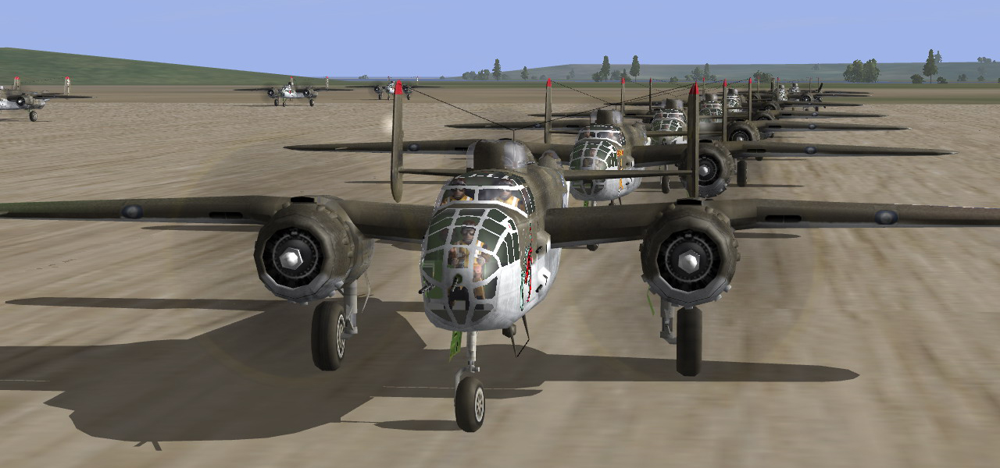

This Chapter will cover all in flight and ground tactics and procedures, from take off procedures and tower operations to in flight procedures for changing positions and emergency safety measures.

Takeoff/landing procedures

Opposed to ‘gaggle takeoff’, take off in the formation or in some order helps to speed up formation forming. There are many ways in which formation takeoff can be accomplished – taking off in pairs, all together or one behind another in short intervals. The last one is the safest take off method and also relatively fast. So that’s the one you should focus on. The other two are for skilled pilots and shouldn’t be conducted with large bomber numbers.

‘Control tower’
To make things easier, we came up with a ‘control tower’. How most of the flying online happens on dogfight servers, pilots are required to taxi to their take off position on the runway manually. After assigning formation positions to all pilots (as described in Chapter One), one pilot is chosen to act as a control tower. He directs planes on the runway according to their number in the formation, first being the sq. leader and tail end being last. With all communication going on over TS at that time, is best to communicate over chat bar for the lineup. As every plane taxies into position, he reports it back to the control tower.
For large formations composed of more elements it is helpful to split elements onto different airfields. This of course requires more people acting as control towers so in general it is best if those duties are given to sq. / element leaders.
When spawning on the carrier airbase, with all planes spawning really close this tactic should not be used.
During landing procedures this function can also be used, by a plane that lands first. This can happen for whatever reason, wither someone was forced to abandon the run or he was damaged – who ever is first on the ground can obtain this function.

Takeoff
Now that all planes are lined up and ready for takeoff, we’re good to go. Depending on the takeoff method you have chosen, planes should be lined up either one behind another, in pairs, or by the formation layout. No matter which method you use for formation takeoff, the following rules apply to all of them:

- Trim your plane! Trimming is required for taking off in a straight line, or you will steer away from the runway and most likely crash.
- Hold brakes and power up to 60% until rpm increases! This greatly speeds up takeoff, and is best used when taking off in a line.
- Use two second delays between planes taking off! When taking off in a line, plane which is next for takeoff powers up to 60% while holding brakes when the plane in front starts rolling. If you have a low end PC, then better wait for dust to clear.
- Gradually increase power during takeoff! This prevents steering from course and will help you get the proper feel how much rudder you need to keep the plane on a straight course.
- Use combat flaps! Lowering flaps down to takeoff or even landing position will slow down your plane’s acceleration during takeoff. Depending on the loadout, using only combat flaps or no flaps at all helps in gaining speed faster. In most cases combat flaps will give you sufficient lift for the takeoff. If needed, use take off flaps for takeoffs with large loadouts (such as Ju-88’s loadouts) – but drop them at the very end of the runway.

Often, leader will call out ‘rotating’, which means his wheels just left the ground. All pilots are not required to reports wheels up, only the leader and last plane taking off – tail end.

Forming up after takeoff
When airborne, lead plane must keep his heading and extend away from the runway on a straight course, climbing up to no more that 500m (1640ft). After that, when leader has been signaled by tail end that all planes are in the air, he may start his 180° turn. The rest of the planes then start turning with the leader – towards the location where he will be, not where he is currently, like shown here:

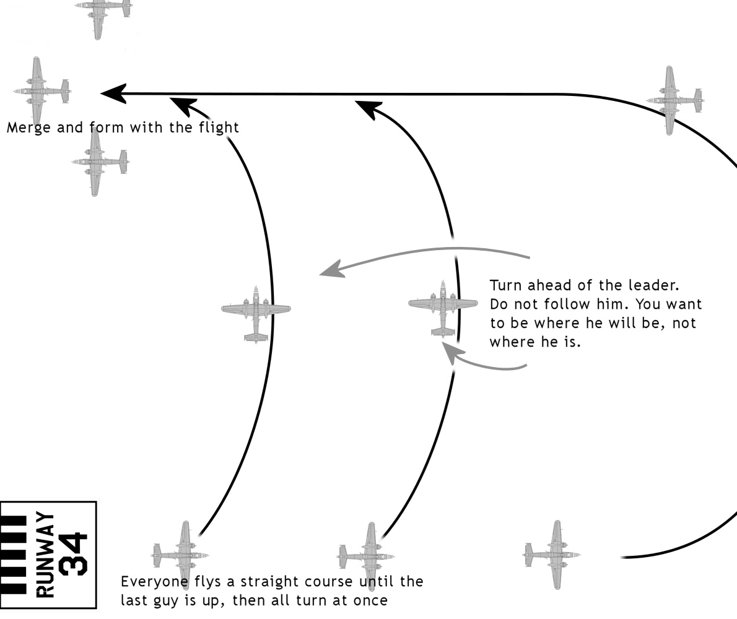

Alternative and quicker method is to form up by flying circles around the airfield. This is best used on dogfight servers and when other described methods aren’t suitable. As always, when forming a large formation that consists of more elements, element leads form up with sq. leader first and then the rest of the planes follow. Don’t bother with runway lineup here as it will consume precious time.

Landing
Although it seems easy and self explanatory, landing over 20 planes on a single airfield after bombing run is much more complicated that you would think. Put into few simple rules, here is what we learned from experience:

- When returning to base, start descending at a long distance from the airfield. Depending on the altitude, use three or four grids for medium altitudes and five or more grids for 5000 meters (16.400 feet) or higher.
- When close to the airfield, planes must line themselves into line astern of the leader (see next subchapter for in flight procedures).
- Upon reaching the airfield sq. leader will start circling around the runway.
  - Circuit rules:
    - Fly left circuit for bombers with pilot’s seat on left side of the cockpit (same rule applies when forming up over runway).
    - Keep a hard deck of 1000 meters and wide circle radius so all pilots can see field = don't make the approach too flat or too steep.
    - First plane to land assumes ‘control tower’ function and instructs other planes to land when runway is clear.
    - When closing in on the course perpendicular to the runway, ask for landing clearance from the control tower – planes don’t need to fly close behind one another. Equal spacing around the circuit is desired.
    - Planes with battle damage and low fuel have advantage on landing and are not obliged to circle the field and wait for landing clearance.
    - Keep rolling on touchdown till the end of the runway.

In flight procedures

This short subchapter describes in flight maneuvers that at first may seem easy and not needing any explanation. Over a year now flying online in formations has taught us that if those things are left out or not even discussed, mid air collisions may and often will occur. Usually accidents like that happen when two guys are doing the same thing. Therefore I have set a couple of rules to go with those in flight procedures.

Switching positions
It is hard to predict everything while still on the ground and assign best positions according to pilot’s flying skills. Someone can have some troubles with his joystick, or find that he is struggling on the left wing. What ever the reason is, you spot that one pilot would be better suited on another’s position and decide to change them in the air, follow these simple rules:

- Pilot with lower position number (closer to the leader) slides out of his position first, by chopping throttle and maintaining his altitude and heading. After positioning himself behind the plane which he is required to replace position with, he signals over TS.
- After the signal, the plane which is positioned further away from the leader (has higher position number) then slides out of his position and, depending on the formation and its layout, then moves into more forward position. When in position, he then signals over TS.
- After the second signal, plane that was until now flying slightly behind the formation moves into his new position.
- When switching positions, you must also switch position number with the plane you’re switching with (remember that fuselage numbers remain the same, only positioning numbers can change – as described in Chapter One under large formations).

If both pilots participating in ‘the switch’ are familiarized with the procedure, then this is an easy thing to do. If this is not the case then sq. leader should guide pilots and his group through this.

Filling empty positions
Even under a protection of close formation it is unlikely that all bombers will return to base. Either by flak or enemy fighters, some bombers will be forced to leave the formation. Formations are designed in a way to use defensive firepower of each bomber to its maximum. If one gets shot down it creates an empty spot and weakens the formation. Depending on the position on which bomber that was shot down was, it is up to the leader to judge the situation weather it is necessary to fill in the blank spot or not. The best example would be if numbers 12 or 13 get shot down. Those bombers cover leader’s (22/32 and 23/33 cover element leads) flanks and are on a stand by if leader himself gets shot down, thus replacing them with bombers positioned next to them is a valid decision.
In VEE formations and VEE elements it is easy to fill in someone’s position. You just move in closer to the leader. All positions can be replaced by other bombers except tail end. Tail end can, however replace any other position.
Same as when switching positions, every maneuver inside the formation needs to be given in advance and signaled over TS.

Changing formation to line astern
This maneuver is usually done when the formation is lining up for landing and to circle around the airfield. And on most occasions, it is called upon during descent. Whenever the situation calls for it, it is important that every pilot knows what he is doing. To prevent from planes from bumping into each other, follow this simple set of rules:

- When order is given, start lining up one behind another in two second intervals, deputies first, tail ends last.
- Every plane drops power to 10% less than leader’s and starts lining up behind the plane with lower position number. When lined up power up again to leader’s power settings.
- In a large formation, planes line up behind their element leaders. When lined up, elements line up one behind another.
- When large formation consists of more elements flying one behind another (VEE for example), elements need to separate from the formation first. Then start forming line astern.
- During landing circuits elements follow their element leads and don’t need to fly together in large formation.

Forbidden operations

In order to be effective, formation flying requires equal dedication from each pilot in it. There are no exceptions or benefits for no one. Formation flying differs from single plane level bombing, in some ways a lot, and again in others very little.

Guns and level stabilizer
When flying in formation, no one is allowed to use defensive guns manually! Formation flying requires 100% concentration from the pilot and leaves no room for errors. Formation is there for a purpose, and that is combined firepower of every gunner from each bomber! It serves as your protection.
No defensive maneuvers are allowed when in formation! Holding your plane still and in the position makes it a very stable firing platform and gives your gunners a far better chance of hitting something.
Use of level stabilizer is forbidden unless you’re leading the formation! Even element leads don't have that luxury, unless they are using Steveiy's gamepad method described in the previous Chapter. And that too is limited to only straight and level flying.

Formation integrity
I have previously mentioned that the most effective use of a bomber, both offensively and defensively, is when it acts in team as a single unit. Every gun on a bomber is designed to give the formation maximum defensive firepower. That is what I mean by formation integrity.
Presuming that pilots are assigned to positions best suited to their flying skills, there should be no stragglers. If, however there is someone struggling to keep up with the formation, either damaged by enemy fire or he just slipped out of his position – no one is allowed to leave the formation and help him out. A crippled airplane has to be expendable. The one thing which is never expendable is your obligation to the group and the formation. 8th Air Force study during 1943 showed that 50% of losses were planes falling out of the formation.
If you happen to get damaged and are forced to leave the formation, it is best to drop your loadout and turn for home. Enemy fighters like nothing better than a bomber that is unable to keep with the formation and no longer under mutual defensive cover. In such occasion, diving for the deck helps as it will force enemy fighters to follow you and thus stay on your six o clock which gives your gunners best opportunity to defend your plane.

Chapter Four:
-LEVEL BOMBING-
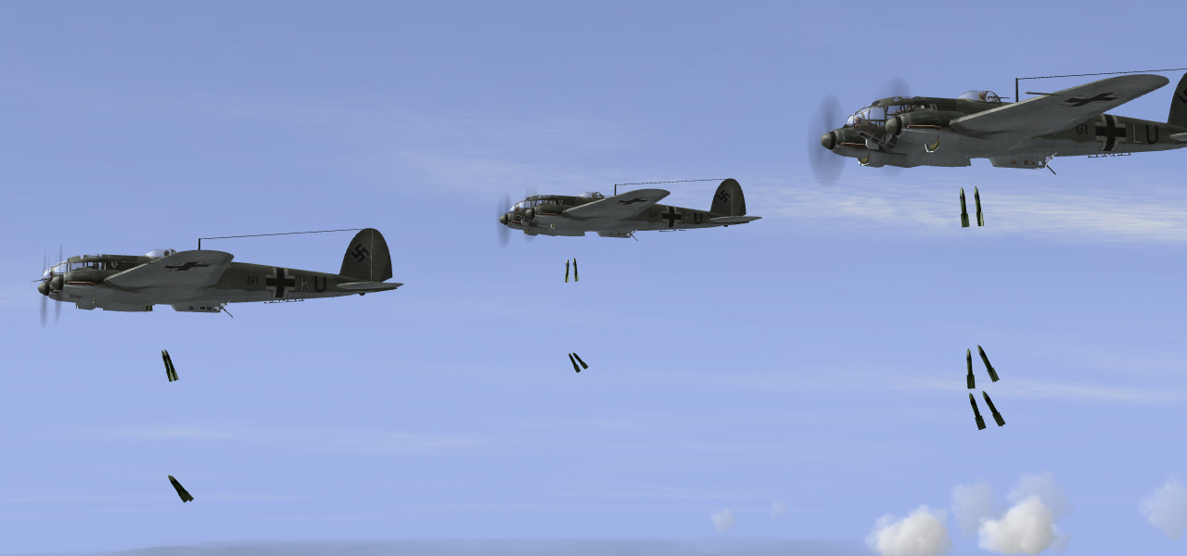

Before being able to use bomb sight properly you have to be familiarized with level bombing tactics, either single plane or in formation. General principles apply for both tactics, but with some distinctive advantages/disadvantages for each one. Before I start describing them, there are some things you must do first before taking off on a mission.

Target recon’ & pre-flight setup

For starters, you have to know is it is even worth level bombing the target. Here are some small guidelines on how you should choose your target:
- Suitable level bombing target usually consists of several buildings and static objects positioned close together. Good examples are industrial targets like various factories or harbor facilities, hangars on any airfield or even vehicles or planes parked close together.
- On dogfight servers where all targets are static, some other targets can also be taken into consideration. Examples are large ships (carriers and battleships), vehicle columns, trains and such. On coop servers it is best to use some other tactic to destroy these targets.
- Using level bombing to destroy targets that are small and scattered over large area is not the best tactic. For such objects it is best to use fighter bombers which can then do pinpoint accurate attacks.

In the end, it all comes down to your experience and skill in level bombing. Before you decide on level bombing, you need to have some information on the target first. The most important one is target’s altitude. This will affect your bombsight angle and aiming, but more on that in Chapter Five. Also, it is good to know target’s position in relation to Earth’s poles (North Pole) when you’re looking at recon’ photos. Depending on target’s size and dimensions, this can help you in plotting the best course for your bomb run with which you can place most of your bombs on the target.

Bomb type and delay

Not all bombs can be used for level bombing. There are three main differences between bombs in IL2. General purpose high explosive bombs, cluster anti tank bombs and armor piercing bombs. If you’re interested you can find detailed info about bombs in IL2 by following this link:

http://www.battle-fields.com/commscentre/showthread.php?p=153887

It is best to go with general purpose bombs because there is no difference in how IL2 handles armor piercing bombs compared to general purpose ones. Most common mistake you can see online is when people take AB cluster bombs (Luftwaffe) for level bombing. Avoid AB bombs unless you’re doing ground attack on enemy vehicles.

Airfield attack
Level bombing from high altitude means that you won’t be caught in your own bomb blast. So there is no need for any bomb delay. Only one target makes using bomb delay logical - enemy airfield. Even then, bomb delay is useful only when you’re attacking together with another bomber or preferably more of them.
Main purpose of using bomb delay here is to score another kill when enemy plane re-spawns. Experience showed that it is best to use seven to ten second delays on each pair of bombers inside a formation (one of the two bombers uses no delay).
From bomber pilot’s view, enemy airfield is the most enjoyable target to hit. It presents the only ‘legal’ tactic to vulch someone on majority of IL2 servers. On the other hand, it is also the most defended one and hardest to hit to get some kills. Experience showed that there is no point in attacking enemy airfield unless following two conditions are met:

- Server is full or nearly full. This presents the best chance to catch someone on the ground.
- Enemy team has only one or two airfields at their disposal, preferably only one. This also increases chances in finding enemy planes still on the ground or taxiing.

When attacking enemy airfield you need to be high as possible if you’re ever planning to get back to your base. Even at high altitudes chances are high that your bomber or bomber formation will be spotted and enemies nearby alerted. Not to mention the flak that is always deadly around enemy bases.

Single plane level bombing tactics

Level bombing is very easy and basically a pretty straightforward method of destroying enemy targets if you follow instructions in this subchapter.
After you have selected your target, got a proper info about it and equipped your aircraft for the attack, it is time to go level bombing. For a successful drop, find the best flight path to the target on the map, by avoiding enemy flak and fighters as much as possible. Select a start point for your bomb run away from the target - remember that a bomb run is a part of your mission where bombardier controls the plane and your bomber is most vulnerable to enemy fire. During bomb run your plane must fly straight in a line to enable your bombsight to center itself and for your bomber to gain steady and constant (cruise) airspeed for accurate drop. Therefore I recommend ‘two map grids distance’ from the target when selecting bomb run starting point. Another important factor is bomb run altitude. Basically, the higher the better = safer you are from flak and enemy fighters.

Using level stabilizer and rudder trim
I already mentioned use of level stabilizer in Forbidden operations, Chapter Three. If you skipped right to this chapter, here is a short explanation what level stabilizer does.
On dogfight servers there is no autopilot option which you can engage to hop into your gunner position and peacefully shoot at your enemies. Instead you must use a command called level stabilizer, and a key must be manually assigned to it in your IL2 controls (under aircraft controls). When activated, level stabilizer keeps your wings leveled with horizon. However, it is not an autopilot and you still have some control of your plane when on level stab. All trim controls still work, but must be applied almost to their maximum in order to observe any change in aircraft’s flight path.
First thing you will notice when engaging level stabilizer is that your plane is starting to lose altitude gradually, no matter how fast you go. This effect is called ‘sinking’ and can be compensated by applying elevator trim, full nose up. All bombers when carrying normal loadouts (up to 2000 total weight of SC bombs on Luftwaffe bombers for instance) with 50% to 75% fuel and up to high altitudes (5000m/16400ft), can hold constant altitude this way. On higher altitudes and with heavier loadouts level stab plus elevator trim will only slow down your sinking. It is important to set another key for resetting your elevator trim to neutral position, so your plane doesn’t nose up abruptly when you disengage level stab. Don’t forget that.
Now we come to the most important part – rudder trim. When on level stabilizer rudder trim can be used for turning your aircraft and aiming during bomb run. Turning the plane when on bomb run will take a very long time so it cannot actually be called turning. Better phrase is correcting your aircraft’s flight path. My estimate is that you can do 10 degree turns max on level stab if you’re still far away from the target, but don’t use rudder trim for turns larger than 5-6 degrees.
Bomb run
This manual covers manual bomb release and this of course means dropping bombs on a predefined bombsight angle. To get correct bombsight angle you must use a program called Bombsight Table 2. It must be loaded before loading IL2, and can then be called on and off screen when needed. When you enter your correct speed and altitude in it, it will compute a bombsight angle for you. Details and explanation how to use it with 100% accuracy can be found in the next chapter.
Upon reaching bomb run start point turn your plane towards the known location of the target. Then engage level stabilizer plus elevator trim and start scanning for it. Depending on how rough you have handled your plane, it will take bomb sight crosshairs to appear for some time, but no longer than three minutes. Often they will appear quickly. Also, it will take some time for your plane to gain steady and constant cruise speed as well. Because of this it is best to use only 70% or 80% power when on bomb run. It takes twice as long to reach cruise speed with 100% power. You can use short intervals of 100 or 110% power to help you speed up to cruise speed (only for single plane level bombing!).
At the same time, if the target has been spotted, start directing your bomber to the target by placing it on the vertical line in bombsight optics. Keep the target above horizontal line and slowly decrease bombsight angle as you approach the target. You control the bombsight angle with only these controls:

- INSREASE SIGHT DISTANCE
- DECREASE SIGHT DISTANCE

You will need to bind a key for those controls first if you haven’t already. During bomb run keep an eye on your airspeed and altitude. Make sure they are matched with those entered into Bombsight Table 2 at all times. When you’re close to the target (bomb release angle), set your bombsight to that angle with suitable offset for that altitude and bomber type*, and release your ordinance when crosshairs reach desired aiming point.
After all bombs have been dropped, you can decrease your bombsight angle to 0 degrees and watch how your bombs travel to Earth. If you have done like I described here, you will be rewarded with destroyed target and/or some kills.

* See Chapter Five for explanation.
Formation level bombing tactics

Level bombing in formation is very similar to single plane level bombing, all rules from there apply here but with some added limitations. The biggest difference is that only one plane is operating the bombsight and that all bombers are targeting the same target. Main purpose of level bombing in formation, besides mutual defensive firepower, is to increase bombing accuracy and effectiveness by putting more bombs on target and also insuring its destruction.
When bombing with formation of bombers lead bomber must never exceed 70 % power. 80%or 90% power can only be used when formation consists of one element and all pilots are experienced in formation flying. I recommend 70% constant power when leading formation and especially during bomb run, so other bombers can keep up and hold formation even if they are damaged.
Another important limitation is Team Speak. Without it manual bomb release loses its purpose.

Deputies and element leads
When on bomb run there is always a danger that lead bomber will get shot down or be forced to abort his bomb run. In order to prevent this, one bomber, usually flying as number two, is selected as sq. leader’s deputy. That bomber is in contact with lead plane and has his bombsight angle set to bomb release angle so he can continue leading the formation if something happens to sq. leader. It is always good to have more than one bomber on deputy duty.
If there are more elements in large formation, chain of command must be established. Recommended procedure is that sq. leader has one or two deputies which can then take over control of the formation if leader gets shot down. If both leader and his deputies get shot down, second element (one with tail numbers 2X) takes command of the formation. On bombing charts provided with this manual, all planes marked with ‘BS X’ next to their position number must have their bombsights set on bomb release angle.

‘5 seconds to bomb release!’
Like I wrote above, you must use Team Speak for accurate bomb release. Team Speak has small delay between when you talk over it, and your participant will always hear what you say with little delay, depending where server is located and you’re speaking from. Then there is human reaction delay. It takes normal person up to 0.5 seconds to react upon receiving the command. When you add game ping and delay to that, we can sum it all on 1 – 1.2 second. Why is this important? Because this is how much sooner you need to shout to other bombers in formation to drop their bombs if you want them to drop with you. (I usually shout ‘DROP!’ three times – formation releases on first ‘DROP!’ and I release my bombs on third and final ‘DROP!’)
Let the formation know how close you are to bomb release. And when you get closer, start the countdown. Example: ‘GET READY: 10 seconds ‘till bomb drop; 5 seconds ‘till bomb drop…’

Carpet bombing
To use level bombing in formation to its fullest strength, study the target before attacking it. When selecting aim point take all bombers into consideration for maximum effect and complete target destruction – select the best bomb run starting point with that in mind.

Manual vs. auto bomb release - pros & cons

Each bombardier has his own preference in level bombing tactic. ‘There is more than one way to skin a cat.’ – Like someone told me. But, manual bomb release is without a doubt more reliable and only usable tactic for accurate online level bombing in formation.
Here are advantages of manual bomb release over auto release:

- Targeting multiple targets on your flight path;
- Dropping one bomb or pair of bombs, not a salvo;
- Dropping accurately with whole formation of bombers by telling then when to drop over TS in advance (with auto release rest of the bombers will hit area behind lead plane’s target);
- Shorter bomb runs (with BT2 you can set up your bombsight easily for fast attacks);
- Formation doesn’t depend on the lead bomber, any bomber can take over at any time;

However, there is one thing that can’t be substituted by manual release. Manual bomb release is limited on targets that are located on sea level or very close to it. On auto release you only have to subtract target’s altitude from your bombsight altitude. There is a way to compensate for this, but not for targets that are over 600m sea altitude. Luckily, in IL2 99% of targets lay on sea level. Very rarely you can find a target which is higher than 200m, and what to do when you come across a target that is not on sea level - you can find in the next chapter.

Chapter Five:
-OPERATING THE BOMBSIGHT-
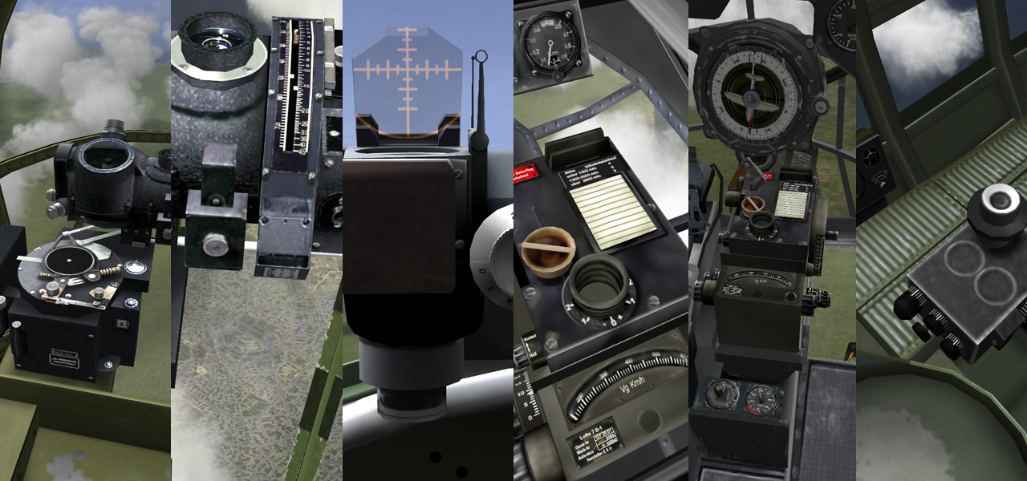

Now that you know how level bombing works, it is time to learn how to operate the bombsight and achieve 100% precision hits. In previous chapter I have listed two important commands you which must bind a key to, plus trim controls that you need for the bomb run. Sum of all needed commands can be found in Chapter Eight.

Requirements

Bombsight Table 2
You can put away your complicated TAS/IAS conversion tables for manual bombing now and download this:

http://mission4today.com/index.php?name=Downloads&file=details&id=317

This is a program called Bombsight Table 2 – a very handy utility created for IL2 by WT_Pedropan & WT_Pitr, couple of years ago. It stays on your screen on top of your game and you can bring it on and off anytime you like (SHIFT + PAUSE/BREAK). It looks like this:

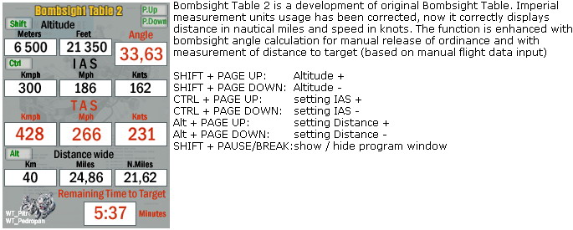

As you can see from the picture, top line shows altitude values in meters and feet plus bombsight angle, second line from the top shows IAS (Indicated Air Speed) values in Kmph, Mph and even Knts (Knots per second), third line from the top shows the same IAS calculated values in TAS (True Air Speed) values while last line can be used to calculate estimated time to target by inputting current distance to target (one map square in on IL2 map is 10x10 km in size).
Using the program is very simple - press Page Up/Down plus CTRL/SHIFT/ALT to enter your current speed and altitude - and Bombsight Table 2 will calculate the bombsight angle for you. You can even use it for calculating IAS into TAS if you want to bomb using auto release method – very handy to have it when you’re going level bombing in any case. For even easier usage you can bind similar keys in IL2 for adjusting bombsight angle, like this:

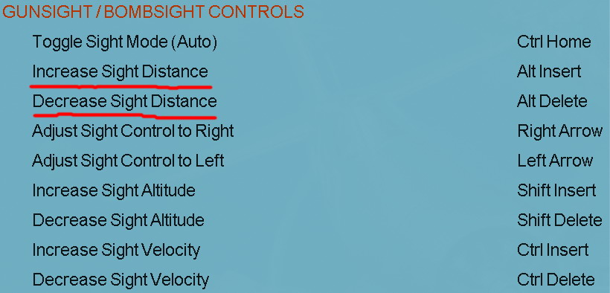
However, there is a problem…

BT2 & BS angle offsets
Since this program has been written some years ago, probably for a different version of IL2, bombsight angle that you get from BT2 will not represent a 100% accurate release angle. To get 100% accurate angle you need to subtract a value from the angle you get from BT2. This value depends on which altitude you are at, and which bomber you are flying. Put in a simple formula it looks like this:

BT2 angle – offset value = true BS angle

To find out the correct offset values I have conducted multiple tests on six main bombers in IL2 which are capable of level bombing. Tests were done on every 1000m altitude starting from 2000m (6560ft) up to 7000m (22960ft). Here is the list of offsets for all six bombers:

 | A-20C | B-25J | G4-M1 | H2 | H6 | Ju-88A4 | Pe-2*
2000m  (6560ft) | 1.5° | 1.5° | 1.0° | 1.5° | 1.5° | 1.5° | MB: -1.5°  BB: -1.5°
3000m  (9840ft) | 2.0° | 2.0° | 1.5° | 1.5° | 1.5° | 2.5° | MB: -2.5°  BB: -1.5°
4000m  (13120ft) | 2.0° | 2.5° | 1.5° | 1.5° | 1.5° | 2.5° | MB: -3.0°  BB: -1.5°
5000m  (16400ft) | 1.5° | 3.5° | 1.5° | 2.0° | 1.5° | 2.5° | MB: -3.0°  BB: -1.5°
6000m  (19680ft) | 1.5° | 2.5° | 1.5° | 2.0° | 1.5° | 2.5° | MB: -3.0°  BB: -1.5°
7000m  (22960ft) | 2.0° | 2.5° | 2.0° | 2.5° | 1.5° | 1.0° | MB: -2.5°  BB: -1.0°

I chose 2000 meters as a starting point for low level bomb runs because less than that will make you easy target for flak gunners. On altitudes below 2000m there is no change in bombsight offset value. Values at 2000m work down to 800m (tested), and should work on even lower altitudes. If not, then just subtract 0.5° from offset value (not BT2 value!). This goes for all bombers equipped with bombsights. I used 7000m as top limit because in IL2 targets are extremely difficult to spot above it, and level stabilizer has no effective use there.
For those altitudes listed in the offset table and their corresponding offsets, and I can guarantee a 100% hit. But when you are bombing on altitudes between those listed (4500m/14760ft for example), some bombers require interpolation (using middle value) of offset values before subtracting them from BT2 angle. This will give you the correct angle. Some bombers have very small deviations between offsets on different altitude, while He-111H6 has constant BS offset on all altitudes.
*As you can see, there are MB and BB offsets under Pe-2 section. During testing with different loadouts I noticed a significant difference in bomb trajectory when using different loadouts. Therefore MB and BB had to be introduced. MB stands for ‘Middle Bombs’ – all bombs up to FAB250, while BB stands for ‘Big Bombs’ – FAB500 bombs only.
OPB1 bombsight is very easy to use and the only one that features manual release by default. Therefore I suggest you use it the way it was designed to, because with that method you don’t need to worry which bomb load you took. Only downside of this method is that you must use TAS, while with BT2 method you can rely on your IAS only (use BT2 for easy and fast IAS>TAS conversions). Here is an excellent manual which describes how to use OPB1 with 100% accuracy:

http://mission4today.com/index.php?name=Downloads&file=details&id=1711

- Credit for this manual goes to II/JG4_Ivank.

Quick reference bombing chart
To save you from writing these offsets to a peace of paper, use this quick reference bombing chart. It contains offsets for all bombers (except Pe-2) together with quick bomb angles for bombing without calculation. It also has a compass rose which is useful for manual navigation.
After consulting with couple bomber pilots, I’ve decided not to include Pe-2 offsets in the QRBC. There are two reasons for this: original method is simpler and putting additional offsets would require different design of QRBC.

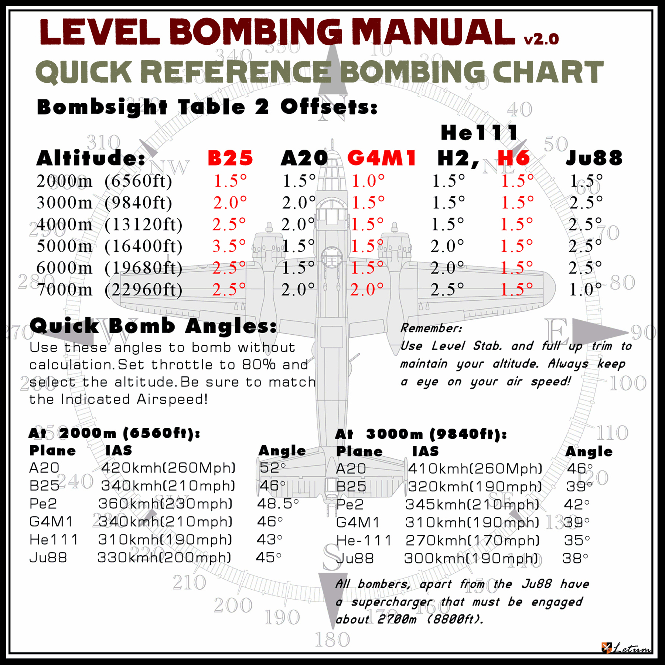

- Printable version (A4) can be found in the same directory where you extracted LEVEL BOMBING MANUAL v2.0.

Target altitude and aiming point

One of the biggest disadvantages of using manual bomb release by BT2 is that it only works for targets on sea level. However, there is still a way to compensate for this.
Let’s talk theory first. In real life and in IL2, air density decreases the higher you go. This is also reflected on IAS and TAS. On sea level IAS equals TAS, but the higher you go difference between them is bigger. Now, BT2 calculates correct TAS for the altitude you give it, and this is all cool and handy – but when you try to calculate BS angle for the target which isn’t on sea level – IAS (TAS) will change too! With auto bomb release you can input TAS and altitude above target separately, while in BT2 IAS (TAS) values are directly linked with altitude. If you try to enter altitude and speed values independently in BT2, for example: correct altitude above target and then manually adjusting TAS – BS offsets won’t work. Therefore BT2 can’t be used for bombing targets that are above sea level – this is only partially true! On altitudes up to 600m (1968ft) air density is still very much the same, and difference between IAS and TAS are very small (~10 Kmph, depending on your speed). Because of this bomb trajectory isn’t affected. For those targets you can enter correct altitude above target in Bombsight Table 2. It won’t affect IAS (TAS) significantly. Just don’t forget to use BS offset for the altitude you are bombing from!
As you can see, target altitude is very important. Study your target before attacking it! Luckily, on IL2 dogfight servers you will very rarely encounter targets that are above sea level, let alone above 600 meters. Highest target I ever had to bomb was at 500 meters.

When using the automation bombsight release, the bombsight crosshairs will show you where the last pair of bombs will land. With manual bomb release method this isn’t the case. Release your ordinance when crosshairs are over target and this is where your bombs will start landing.
All bombsights have small crosshair lines which are easy to place over target, except OPB1 which has a circle. Center of that circle is where your bombs will land. However, if you have decided to use BT2 method for level bombing with OPB1, for 100% accurate hit you must release your bombs when target reaches top of the aiming circle, like shown here:

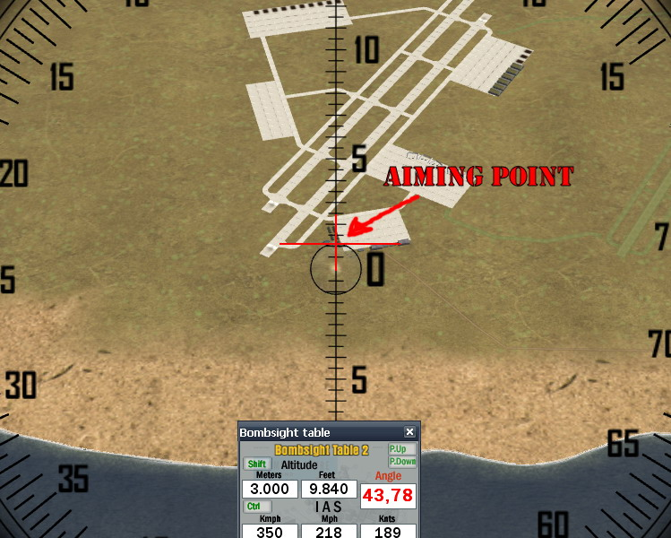

Importance of speed over altitude

Speed is the most important part of getting bombs on target. Even if you enter 100m (328ft) from the correct altitude, your bombs will hit where you aimed at.
The best thing about Bombsight Table 2 bombing method I described here is that you don’t need to use TAS! IAS is the only thing that you need. TAS will be calculated for you by BT2.
When you look at Bombsight Table 2, you will notice that it inputs km/h in decimal numbers and Mph in every 6 Miles. This is very much related to in-game speedbar, which also shows speed in a similar way. Since correct speed must be entered into the BT2 it is best to rely on instruments. All important instruments for level bombing can be found in bombardier’s compartment (for most bombers). Trouble is this – speed (IAS) shown on speedbar can be anywhere between the value showed and next decimal value. Higher value will only be shown when current speed matches that value. Example: if your plane is flying at 310 km/h, shown by speedbar, you could be doing 319 km/h as well. Only when you reach 320 km/h speedbar will show 320.
Another method of verifying the correct speed is to ask other bombers in formation if they are doing the same speed as your speedbar tells you. If speedbar tells you one thing and plane which is flying on your wing another, then this means you need to input higher value into BT2.
By either learning plane’s cruise speeds or by reading from instruments, you must enter the correct speed value into the bombsight. Everything else will cause missing the target. See next chapter for details on what to expect from each bomber when you use speedbar for calculating speed.

Chapter Six:
-BOMBERS-

In this chapter you can find everything a pilot needs when going level bombing. Descriptions of six main level bombers in IL2, their recommended trim settings, how well they handle in formation and what you can expect from each one. Some things we learned from experience by flying all six of them in formation far behind enemy lines and back. Trim settings are for keyboard trimming as I cannot tell you how much trim you need when using HOTAS joysticks.
All trim settings have been tested for level flight at 3000m (9840ft), at 70% power with full bomb load and 50% fuel. All planes had second stage supercharger engaged.
Two bombers have been excluded from this manual – TB-3 and Arado Ar-234-B. TB-3 was excluded because it has very easy to use bombsight and with BT2 you can do fast IAS>TAS conversions. Ar-234-B has been dismissed due to its defensive firepower - it has none. Well, none that would be of any benefit when flying in formation. However, since I am a bomber pilot I had couple bombing runs in it and on altitudes up to 2000m (6560ft), using a simple 1.5° offset will give you accurate bombing angle.

A-20C
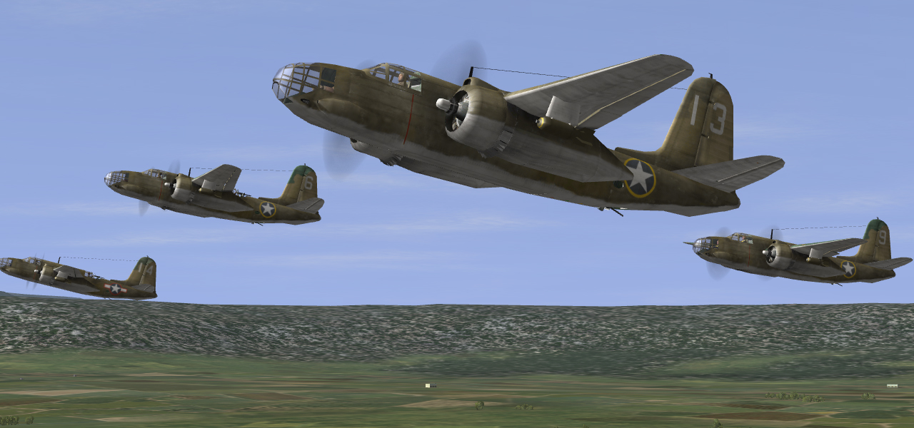
Bombsight behavior:
A-20C bombers use famous Norden M8 bombsights, which can be used for both auto and manual release. Because of their fast acceleration they have a tendency to fly at speeds which are not correctly represented by speedbar – the ‘upper value’ as I mentioned before. Therefore always keep an eye on instruments in your plane! I suggest that you use Mph when operating with this bombsight.

Short description:
A-20C is a very fast and capable medium range tactical bomber. It can be used for both high and low level strikes. Because of its speed, it takes longer to reach constant cruise speed than other bombers. Use higher power settings for a short interval then power back to cruise settings to compensate for this. It can carry decent bomb load for its size, but remember that biggest bomb loads also cause drag and decrease your airspeed significantly.
Its weak points are poor defensive firepower coverage (limited to only six o’clock) and weak wings. Usually one shot between engine and fuselage will de-wing it. When not in formation, speed is your best weapon.

Cruise settings & flight characteristics:
- Reset trim to neutral, and then apply 18 clicks of right rudder.
- Holds altitude very good and starts sinking on higher altitudes than other bombers.
- Stage 2 supercharger should be used above 2200m/7216ft.

Formation handling & cockpit visibility:
- Very stable and easy to maintain formation with.
- Controls are very responsive and user friendly.
- There is no copilot and cockpit has very good visibility which makes this bomber capable of flying in any type of formation and on any formation position.

B-25J
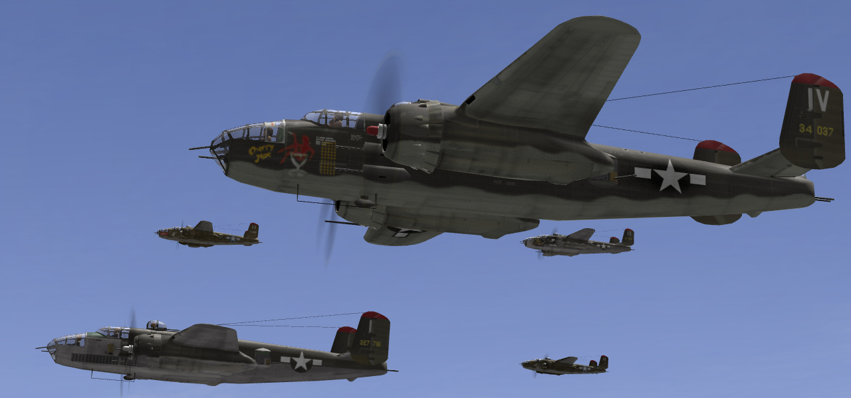

Bombsight behavior:
Like A-20C, B-25J is also equipped with Norden M8 bombsight. Always keep an eye on your speed, especially on higher altitudes where B-25 requires very accurate speed input combined with large BS offset. It uses Mph as default measure units – the best method for finding out the correct airspeed is to compare Mph shown on speed gauge with the one in BT2.

Short description:
B-25J is a fast and durable bomber, and has huge benefits from formation flying because of its great defensive firepower. It will reach constant cruise speed almost right after you engage level stabilizer. Only shortcoming is its relatively light bomb load. Use 3x1000lb loadout only when you’re attacking an airfield. For all other targets 6x500lb bombs are your best option.
Another thing we found out is that it has a nasty habit of rapidly losing fuel when hit by flak. Sometimes 50% fuel won’t be enough to reach base if mission is very long.
B-25 is equipped with fire extinguishers – don’t hesitate to use them.

Cruise settings & flight characteristics:
- Reset trim to neutral and then apply 22 clicks right rudder.
- Very little trim correction is needed when you’re changing power settings.
- With 50% fuel and on 6000m (19680ft) you can almost stop her from sinking completely. With 75% fuel she will lose altitude above 5000m, even with level stab plus full elevator trim.
- Stage 2 supercharger should be used above 2800m/9184ft.

Formation handling & cockpit visibility:
- Stable and easy to hold formation with.
- Good maneuverability.
- Right wing is easier to fly than left wing, but with little practice it is very easy to fly this plane on any position.
- Cockpit is clear and unobstructed with bars, suitable for any formation position.
- When in formation you must disable waist gunners as they have a tendency to shoot your wingmen down (see Chapter One).

Pe-2 (All variants)
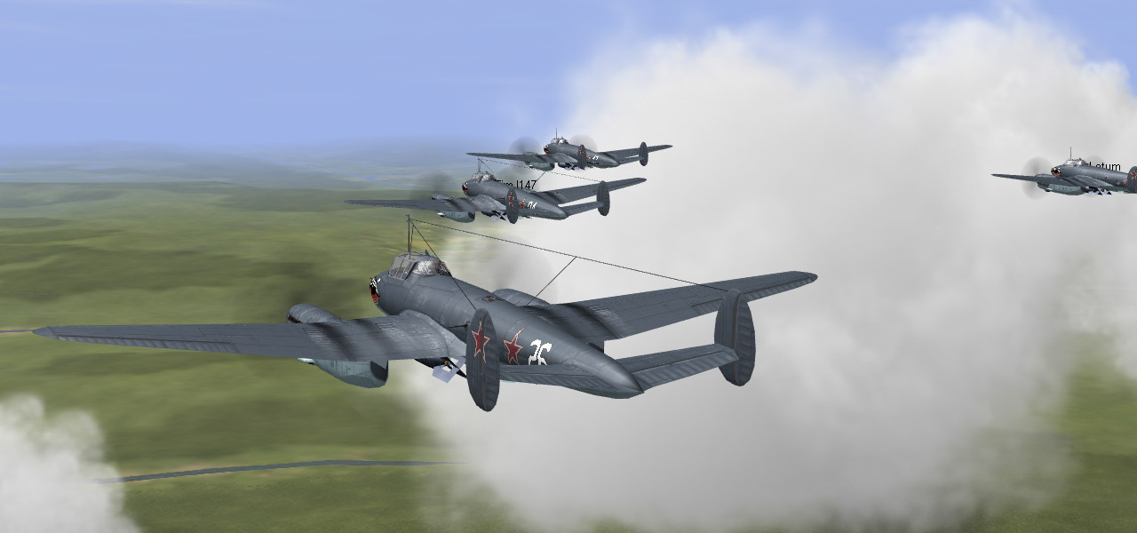

Bombsight behavior:
OPB1 bombsights used by Pe-2 bombers are one of the easiest to use, and only ones featuring manual release as default in-game method. They are also the most accurate bombsights in the game because of their ability to fine tune between different bombsight angles. It takes three clicks to switch to next degree. This is very useful because you can set your bombsight to a 1/3 of each degree angle.
When comparing BT2 method of level bombing with default one, there are few advantages of each method. With default one you’re not limited to bombing targets at maximum 600m (1968ft) sea altitude, bombsight will calculate the exact angle for you and you don’t have to worry which bomb load you took. With BT2 you don’t have to use TAS.

Short description:
Same as A-20C, Pe-2 bombers are the fastest ones described here. Unlike IL-2, Pe-2 is very vulnerable to enemy fire. Early variants have weak defensive armament and its defensive firepower coverage is limited to only six o’clock. They are capable of carrying up to 1000kg (2200lb) of bombs.
Pe-2 is also equipped for dive bombing. With its weak defensive coverage it won’t stand long against 190s when flown in formation. When large concentration of enemy fighters is present, this bomber is best used for single plane precision strikes.

Cruise settings & flight characteristics:
- Reset trim to neutral, then apply 18 clicks left rudder. On 359 series only 16 clicks are needed.
- Up to 4000m (13120ft) it has excellent performance and holds altitude.
- Supercharger/mixture settings (all variants before 359):
  - Stage 2 supercharger should be used above 3100m/10168ft.
  - Mixture adjustment:
    - 100% at 3200m/10469ft
    - 80% at 4600m/15088ft
    - 60% at 6300m/20664ft
- Supercharger/mixture settings for 359 variant:
  - Stage 2 supercharger should be used above 2800m/9184ft.
  - Mixture adjustment:
    - 100% at 1650m/5412ft
    - 80% at 3150m/10332ft
    - 60% at 4850m/15908ft

Formation handling & cockpit visibility:
- Excellent maneuverability.
- It has very sensitive controls and this requires steady hand in order to be flown well in formation. I recommend toning down your stick axes if your feel that she is too responsive.
- Cockpit has excellent visibility and Pe-2 can be flown on any formation position.
He-111H2
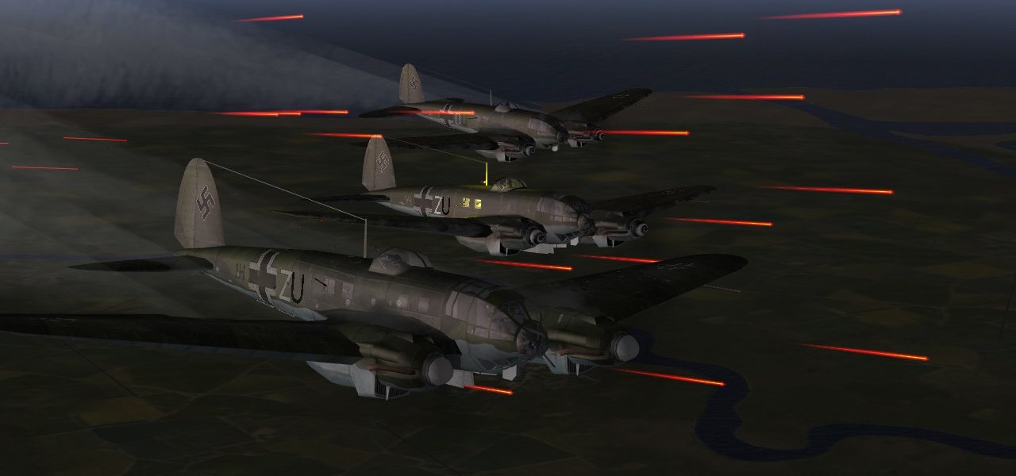

Bombsight behavior:
Luftwaffe bombers use Loffte 7S bombsight which is very similar to Norden bombsight used by allies. Heinkels will reach steady cruise speed fast enough after engaging level stabilizer and accurate speed value can often be read from infamous speedbar. No matter how often it shows accurate value, don’t rely on it. Good indication that you haven’t entered correct speed is when needle on the speed gauge is pointing well above the ‘upper value’.

Short description:
Heinkels have very good defensive gun coverage but their guns lack power compared to .50 caliber guns on B-25. Still, flying in formation benefits this bomber and is its best defense. H2 variant is early version which has very good flight characteristics and can carry medium bomb loads. Not many pilots know this, but in a dive this plane can reach very high speeds compared to early war counterpart planes. This can be used as a tactic to force your attacker to get on your six o’clock, thus making it easier for your gunners to finish him.
The biggest disadvantage is its low speed and glass nose which doesn’t protect pilot and bombardier (head-on attacks often end in worst possible way). Heinkels also suffer from lack of fire extinguishers. When on fire this means you should bail immediately because fuel tanks explode soon after being lit up.
There is one thing related to Heinkels that irritates most pilots, and that is ground handling. Don’t use more than 30% power when taxiing and apply throttle gradually while holding brakes at the same time. If you find yourself spinning power up to 70-80% for two seconds while applying full rudder in the opposite direction. This will stop it from spinning faster.

Cruise settings & flight characteristics:
- Reset rudder trim and apply 21 clicks of right rudder (one click less than H6!).
- Holds altitude even without elevator trim on lower altitudes. When on level stabilizer plus elevator trim it can gain altitude as well.
- Even with biggest loadout this plane doesn’t require any flaps during take off. With only combat flaps it will take off on short runway without pushing the stick backwards.
- Above 4000m/13120ft starts climbing very slowly when in formation.
- Stage 2 supercharger should be used above 3000m/9840ft.

Formation handling & cockpit visibility:
- Sluggish and has very effective rudder. Stepping too hard on rudder can also cause loss of speed. It must be trimmed for easy formation flying.
- Although cockpit is made mostly out of glass, view forward is obstructed by control panel placed above pilot’s head. Flying tail end position is nearly impossible from the cockpit. I suggest that you either fly that position from the bombardier’s position or avoid flying in such formation.
- Left wing is slightly harder to fly than right wing but it shouldn’t be a problem if you follow rules and formation flying guide in this manual.
- When in formation you must disable waist gunners as they have a tendency to shoot your wingmen down (see Chapter One).

He-111H6
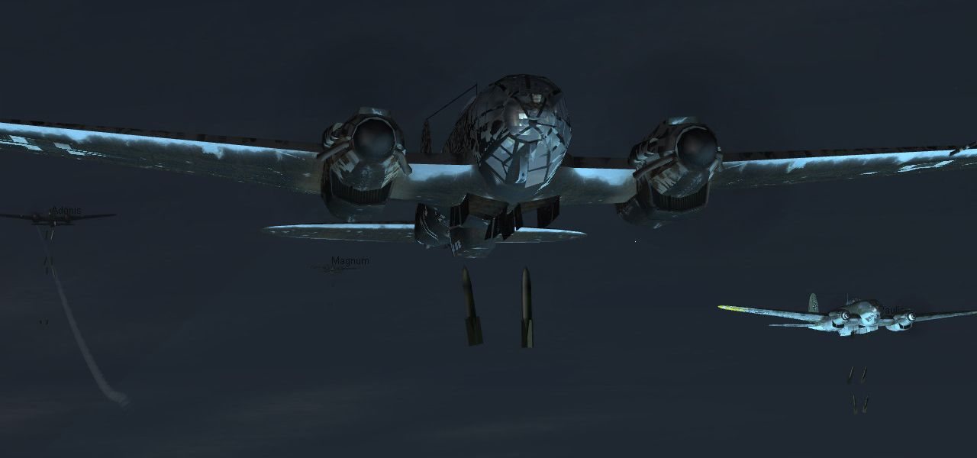

Bombsight behavior:
Same as H2, except one thing - H6 has one large advantage over other bombers, and that is BS offset which is constant on all altitudes.

Short description:
H6 is later version of He-111 and doesn’t differ much from its predecessor, H2. It is slightly faster and better armed. There is one additional machinegun in the tail and it can carry huge loadouts, up to 4000kg/8800lb - almost three times as B-25. While capable in early/mid stages of war, in later stages it is obsolete and very vulnerable to enemy fighters.
When bombing in formation use 4xSC500 or 2xSC1000 bombs. Larger loadouts cause great loss of speed and won’t make big difference. I recommend that you use them only when going bombing alone.

Cruise settings & flight characteristics:
- Reset trim to neutral and apply 22 clicks of right rudder.
- Use whole runway when taking of with large bomb loads. He-111 has big wing surface and this makes it easier to carry large loadouts than Ju-88A4.
- Please refer to the H2 section for rest of description.

Formation handling & cockpit visibility:
- Same as H2.

Ju-88A4
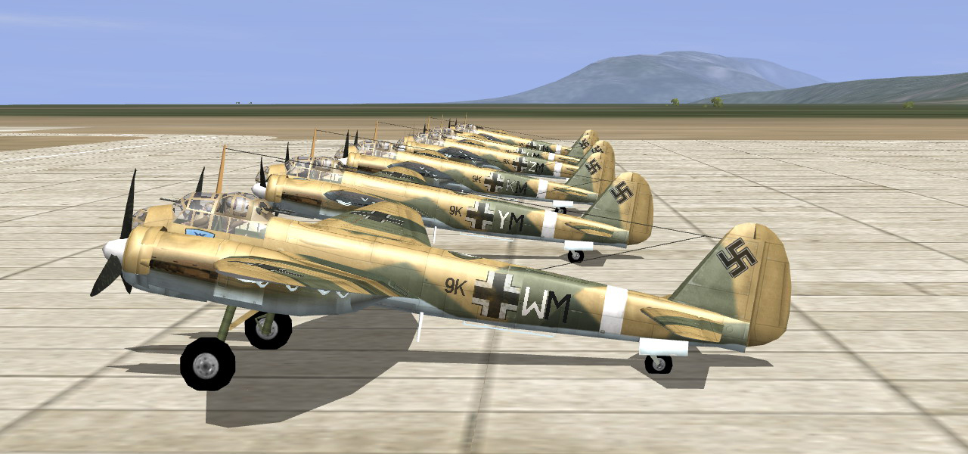

Bombsight behavior:
Ju-88A4 is equipped with Loffte 7S bombsight. Its behavior is practically the same as on He-111. Only difference is that Ju-88 will reach cruise speed a bit later than He-111 so always keep an eye on in cockpit gauges.

Short description:
Ju-88A4 is the most popular plane amongst online pilots. When compared with Heinkels it is faster, more maneuverable and it can be used for dive bombing as well. Because of this, wings had to be strengthened and they have smaller surface than He-111 – above 3000m/9840ft it can’t be fully stopped from sinking. On medium bomb runs you will loose up to 50m from your start altitude, so this isn’t such a problem. But above 4000m/13120ft you will feel the difference. Just like He-111, it is capable of carrying the biggest loadouts. Use them only when bombing alone.
Its weak spots are poor defensive gun coverage and crew being stationed in small glass cockpit which makes them easy to disable. Ju-88 is relatively fast bomber, so use this to your advantage when in trouble. It has no fire extinguishers.
Some pilots find this plane jerky when flown in formation. This only happens when plane isn’t trimmed properly. When trimmed this plane is very nice to fly. With all Luftwaffe planes trimming is crucial for formation flying.

Cruise settings & flight characteristics:
- Reset trim to neutral, and then apply 20 click of right rudder.
- Use whole runway when taking off with large bomb loads and don’t use any flaps until you’re at the end of the runway. This will help you accelerate faster. More than combat flaps are not needed. Retract flaps when you have sufficient speed, Ju-88 will start losing altitude rapidly if you retract them right after takeoff.
- Climbs better than Heinkels, but still very slow above 4000m/13120ft.
- Ju-88A4 has automatic supercharger so you don’t need to bother with that.
- Very tricky to land, land with caution. Consider bailing out if you took damage in tail and elevators section.

Formation handling & cockpit visibility:
- Highly maneuverable.
- When trimmed, very stable in formation.
- In Ju-88 you have an option to choose from both copilot/bombardier and pilot’s seat. Some find it better to fly left wing from the cockpit, but I recommend that you use bombardier’s seat.
- Cockpit has very good all around visibility, except at 12 o’clock high. Stuvi dive sight is located there and obstructs pilot’s view forward up. When flown on tail end position, you must use bombardier’s view or even forward gunners view. Because of this, and the fact that four out of five defensive guns are pointing at 6 o’clock I recommend that you use it mostly in VEE formations with elements stacked on different altitudes.

G4M1_11
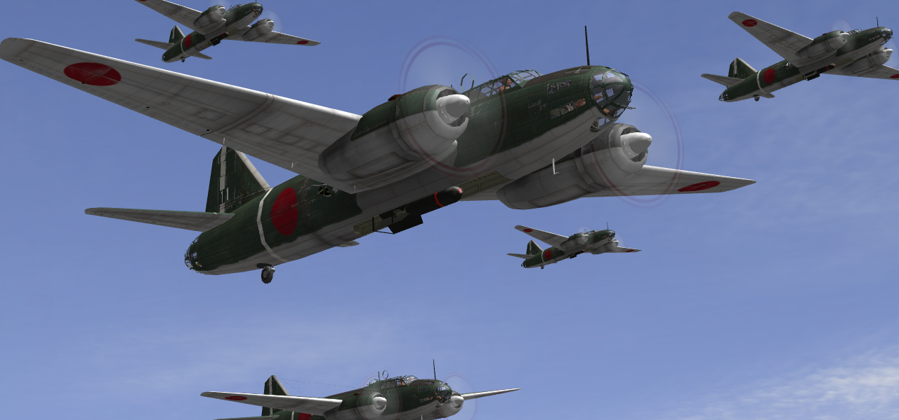

Bombsight behavior:
Bombsight used in G4M1 is the easiest to use when bombing with BT2 plus offset method. It has very small offsets on all altitudes and it will reach cruise speed very fast. I recommend it as a starting point when learning to level bomb if you don’t have any previous experience.
Speedbar very often shows accurate speed, especially on lower altitudes.

Short description:
G4M1 ‘Betty’ is very easy to fly. It will hold altitude on almost all altitudes and is very easy to level bomb with. Its weak points are relatively low bomb loadout and weak structure. Fuel tanks are not self-sealing and will catch fire fast. Luckily, US fighters equipped with .50 caliber machine guns don’t have incendiary rounds modeled like in real life so you still have a chance.
Unlike most bombers that use machine guns for defensive armament, the Betty has a 20mm cannon in the tail. It is absolutely devastating. If any enemy fighters are foolish enough to attack you from behind, use it to your advantage. Besides tail cannon, Betty has excellent all around defensive gun coverage.

Cruise settings & flight characteristics:
- Reset rudder trim to neutral and then apply 21 clicks of right rudder.
- Betty is very stable on all altitudes. On lower altitudes you don’t need elevator trim to hold her.
- Stage 2 supercharger should be used above 3000m/9840ft.

Formation handling & cockpit visibility:
- Very stable and easy to maintain formation with.
- Controls are very responsive and user friendly.
- Pilot seats on the right side, compared to other bombers described here. However, this doesn’t make it easier to fly on left wing because large bar is obstructing view at 45° right (2 o’clock). Other than that cockpit has very good visibility and Betty can be flown on all formation positions.
- Bombardier’s position cannot be used for formation flying because it has very small windows. You must use the cockpit.
- One thing you should take into consideration, and those are in-cockpit gauges. Learn where they are before you’re going to fly on full real servers because everything is in Japanese.
- When in formation you must disable waist gunners as they have a tendency to shoot your wingmen down (see Chapter One).

Chapter Seven:
-LESSONS LEARNED-
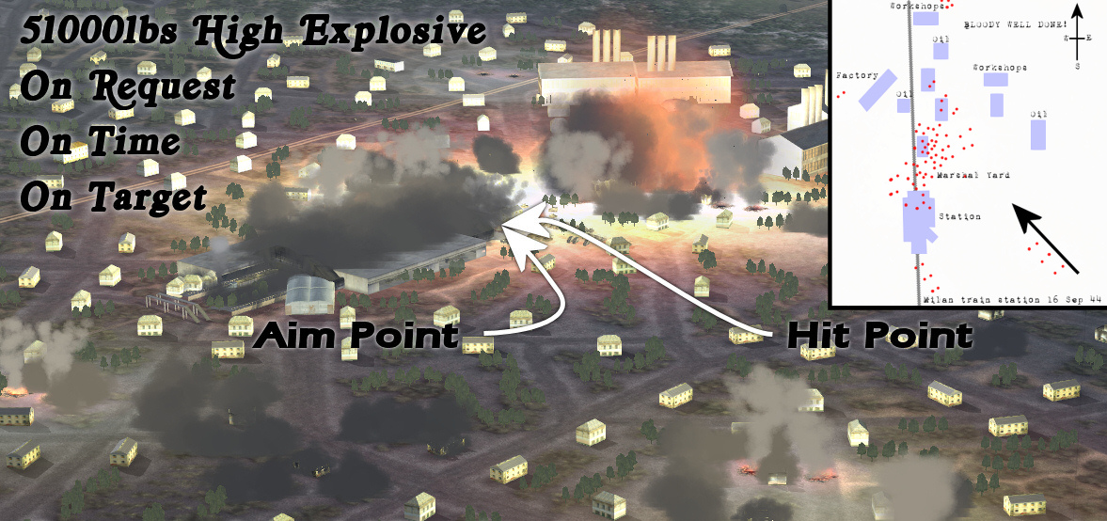

“Gentlemen ~S~. Thank you for the great time. Never have I been part of such a Fun mission with such formation expertise.”
“Thanks for organizing this guys, well worth the wait. Quite a sight looking back at the track whilst taking off.”
“That was a fabulous mission guys - a pleasure and an honor to take part in.”
“That was TREMENDOUS fun. I'm really a better fighter pilot than bomber pilot, but I hung on well enough, I hope.”
…

These are just few of many comments there usually are after a good bombing event. But things aren’t always so simple and easy as they seem. Organizing a bombing night and the effect it has on dogfight server are things worth mentioning. We learned this the hard way. I saw similar attempts on other servers like Warclouds, so I decided to put down few tips for everyone wanting to organize something on this scale.

Level bombing on dogfight servers

Without a doubt, level bombing is something that promotes great teamwork and raises game play level much higher. But it does have its downside. Going level bombing on dogfight server with inexperienced crowd can lead to few things you might not expect.
First of all, you will get vulched on the ground if you attempt to form up that way. Briefing and having same loadouts on all planes is very time consuming if everyone doesn’t know what they are doing. Secondly, the most used tactic is to take a large detour to target, in order to avoid being molested by enemy fighters. Depending on the size of the formation you’re flying in and maximum limit of players on the server – it will cause boredom for the other team. In the end players will start leaving the server or, and this has happened on several occasions, start doing JABO missions and eliminate ground targets before you even reach your own target.
This all implies to full real servers without externals enabled. On servers with cockpit off or with externals enabled things are even worse. Bomber formations will immediately become the most wanted target. There is something irresistible in attacking a bomber formation. Here lies another problem – most pilots don’t know how to attack a bomber formation so they either end on formation’s six o’clock which is good because combined firepower of the formation will deal with them fast and effective. But, other half of inexperienced pilots doesn’t know how to judge distance and are too eager to shoot someone down – which often ends up as collision. You may even go unnoticed on the first run, but second time everyone will leave what they were doing and attack you. Taking the biggest gun available, even if it is anti tank weapon is what will happen on most occasions.
Why level bomb then when there are so many bad things related to this method of destroying targets? Well, that’s why I wrote this manual. With methods described here, you will find that level bombing is a very effective and enjoyable thing to do. Learn them. These methods work and have been tested numerous times. I flew fighters exclusively for over a year before I took up a bomber. Now I feel I wasted that year on flying fighters. Nothing gives me more pleasure than level bombing online, or doing something that promotes teamwork. Be it JABO, CAP or something else. There are those who doubt that level bombing in formation is a valid tactic on online dogfight servers. This manual proves it is.
When flying on dogfight servers, always try to have some escorts with you. Without escort fighters even the biggest and strongest formation is doomed. If you find yourself without fighter cover, flying close and tight is your best defense.

Here you can find some links and AAR-s of bombing runs we did on UK Dedicated servers.

BFs visit to Zekes vs. Wildcats:
http://www.battle-fields.com/commscentre/showthread.php?t=17885
UKD3 Tracks & AAR-s:
http://www.battle-fields.com/commscentre/showthread.php?t=14775
UKD3 bombing tracks (first thread):
http://www.battle-fields.com/commscentre/showthread.php?t=13813
A day on UKD3:
http://www.battle-fields.com/commscentre/showthread.php?t=13895
NJG 88 Heinkels – AAR:
http://www.battle-fields.com/commscentre/showthread.php?t=13832
Night skins & He-111s:
http://www.battle-fields.com/commscentre/showthread.php?t=13767
Nice'n'tight:
http://www.battle-fields.com/commscentre/showthread.php?t=13698
Lady Luck:
http://www.battle-fields.com/commscentre/showthread.php?t=13662
UKD3 on fire:
http://www.battle-fields.com/commscentre/showthread.php?t=13420
He-111's fight back!
http://www.battle-fields.com/commscentre/showthread.php?t=13360
Lucky number 47, story behind 12th Mega Mission:
http://www.battle-fields.com/commscentre/showthread.php?t=13185
Ju-88 in airfield attack:
http://files.filefront.com/3xJu88+Letum+lewilewi+THORrar/;6786178;/fileinfo.html

- I’m not sure if all track links work in there, some threads are over a year old. From the top to the bottom, links have been sorted out by their ‘age’. Latest posts are at the top and the oldest ones are at the bottom of the list. Last link points to one of the first successful bombing runs we did, and still the best airfield run I participated in. You can find all of my uploaded tracks on that File Front account.

Organizing a bombing event

What is a bombing event? Bombing event fits under description of mega mission focused on level bombing. And it should be treated as such. Organizing a formation which consists up to ten bombers isn’t a big problem, but when you’re dealing with twenty plus pilots in the same formation, it requires a different approach.
All pilots must be up to speed with tactics and procedures used when flying in formation. Everyone must know his place, and have the same loadout. Positioning alone takes time. In early days we used to do it over Team Speak, but it was very time consuming. The best and only method of telling every one what to do is to start organizing things in advance. I recommend two weeks as minimum required time when organizing large bombing events, unless you’re dealing with experienced pilots that have flown together before.
Remembering who is who in the formation is not easy when there are twenty pilots in it. Use tail/fuselage markings that correspond to the formation position each bomber flies in, plus printable versions of formations charts to write down pilot names.
Here is an example, large bomber practice held on Warwings server (in association with FALLEN ANGELS) on 16.09.2007.:

http://www.battle-fields.com/commscentre/showthread.php?t=15512

Chapter Eight:
-SUMMARY-
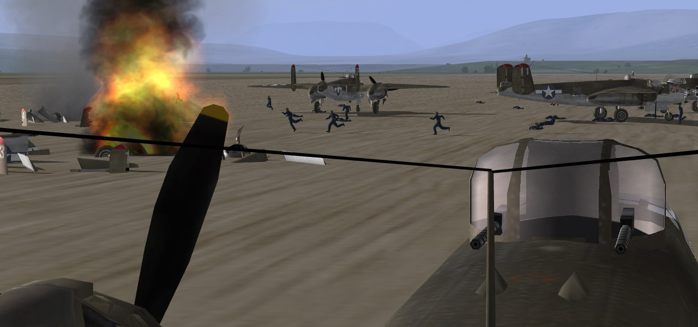

Self explanatory, this chapter contains summary of all needed controls together with all links that can be found throughout the manual. I’ve also added some things you might find useful, like skins and gunnery tutorial.

List of needed commands

AIRCRAFT CONTROLS
- Level Stabilizer
- Elevator Trim Negative
- Elevator Trim Neutral
- Elevator Trim Positive
- Rudder Trim Left
- Rudder Trim Neutral
- Rudder Trim Right
- Supercharger Next Stage
- Supercharger Previous Stage
- Fire Extinguisher
- Feather Prop.
- Weapon 4 *

GUNSIGHT/BOMBSIGHT CONTROLS
- Increase Sight Distance
- Decrease Sight Distance

- The rest of the controls are for auto bomb release and Pe-2 default bombsight operation.

VIEWS
- Jump to Cockpit # 1 (Pilot)
- Jump to Cockpit # 2 (Bombardier) **
- Vide View
- Normal View
- Gunsight View

MISC
- Toggle Level Autopilot ***

* Bomb release control, I recommend that you bind a combination of two keys for this so you don’t release your ordinance by mistake.
** Use this command for fast switching between pilot and bombardier’s position which saves time from going through all gunner positions.
*** This control plus Toggle Autopilot (default ‘A’) enables/disables your gunners when switching between different positions. You must use it when flying as a lead plane to disable your waist gunners (see Chapter One for explanation).

Useful links

SUM OF ALL IMPORTANT LINKS
(In the order of appearance)

Home of UK Dedicated servers:
www.battle-fields.com

Main thread about this manual:
http://www.battle-fields.com/commscentre/showthread.php?p=207106

USN Training Film dating from year 1953. (25 min running time):
http://video.google.ca/videoplay?docid=-1997892837826774725
Team Speak & TS Overlay:
http://www.goteamspeak.com/
http://www.teamspeakoverlay.com/

Different bomb types and their explanation:
http://www.battle-fields.com/commscentre/showthread.php?p=153887

Bombsight Table 2:
http://mission4today.com/index.php?name=Downloads&file=details&id=317

OPB1 Bombsight Operation:
http://mission4today.com/index.php?name=Downloads&file=details&id=1711

SKINS
Skins which we use can be found in the links below. Most of them have been used in this manual. Please note – for skins that are located on Flying Legends site you need to be registered there before clicking on them. Registration is free. Otherwise every link below will lead you to the main page.

B-25J
310th and 321st BG by Monguse:
http://www.battle-fields.com/commscentre/showthread.php?t=16847
No. 180th Squadron RAF by Monguse, final polish by Nightshifter:
http://www.warwingsart.com/WarWingsServer/MissionSkins/B25J_180thSqn_BFMission.zip

He-111H6
KG55 by Buglord:
http://www.mission4today.com/index.php?name=Downloads2&file=details&id=2216

Ju-88A4
III/KG30 by Buglord:
http://www.flying-legends.net/php/downloads/download.php?id=136
6/KG30 by Buglord:
http://www.flying-legends.net/php/downloads/download.php?id=135

G4M1_11
Kisarazu Kokutai 3rd Chutai by Graf:
http://www.flying-legends.net/php/downloads/download.php?id=2533

G4M1 Camo by Graf:
http://www.flying-legends.net/php/downloads/download.php?id=819

OTHER BS MANUALS
Link below points to collection of manuals on Mission4Today site, amongst them is probably the best video manual for auto bomb release out there, made by Joe90.

http://mission4today.com/index.php?name=Downloads&c=547

GUNNERY TUTORIAL
On occasions when you will be bombing on your own, it is good to know how to use your guns to defend yourself. Follow these tips (from Crash Moses B-25J guide):

http://www.airwarfare.com/guides/b25podm/8.htm

-CREDITS-

- QUICK REFERENCE BOMBING CHART
- Formation charts – printable versions
- Visual aids
- BFs logo (redrawn in higher resolution, original by BoneHead)
Letum

- LEVEL BOMBING MANUAL Cover
Magnum

- In-cockpit shots pilots: [bfs]Letum, [bfs]Steveiy, FA_Magnum, FA_Monguse, Trogdor, Joe2L, [BFs]Bladebender, [BFs]Cinnibar, [bfs]Blasny, [bfs]Fodder, Paulie, DD_Tonar, MaSkullKo, Peeet, Solnyshko, Rocket_Man, Luxchamp, [bfs]Tim, lewilewi and [bfs]T.}{.O.R.
- Hosting and maps for in-cockpit shots
Bladebender

- LEVEL BOMBING MANUAL v2.0
- Formation charts
- Screenshots
T.}{.O.R.

- ‘Beta readers’: [bfs]Letum, [bfs]Steveiy, [BFs]Bladebender, FA_Magnum, Irish, FA_Monguse, [BFs]Cinnibar, Happy, Luxchamp

That’s it. I hope you have enjoyed your reading. Version 1.1 of the manual helped a lot of people to brush up their level bombing skills, so I’m sure this version will help you further improve them. This is my last manual/project until Storm of War: Battle of Britain comes out or at least for a long time, but who knows. Happy bombing!

Author: Hrvoje Topličanec, call sign “T.}{.O.R.”

